









MINISTRY OF HEALTH

OF THE REPUBLIC OF BULGARIA

CONCEPT

“OBJECTIVES FOR HEALTH 2020”

SOFIA

2015

INTRODUCTION

Health 2020 is a value- and evidence-based health policy framework for health and well-being among the people of the WHO European Region. The hope is that Health 2020 will provide understanding and inspiration to everyone across the European Region who wishes to seize new opportunities to improve the health and well-being of present and future generations, by showing the challenges, opportunities and ways forward. Health 2020 is for everyone: not just politicians and experts but also civil society, communities, families and individuals.

Health 2020: a European policy framework supporting action across government and society for health and well-being

Reaching the highest attainable standard of health is one of the fundamental rights of every human being.
In 2012 all 53 Member States of the WHO European Region adopted a new common policy framework – Health 2020.
By this the countries in the WHO European Region confirm their responsibility for ensuring the right to health and assume the commitment to introduce universality, solidarity and equal access as the guiding values for organizing and funding their health systems. They aim for the highest attainable level of health regardless of ethnicity, sex, age, social status or ability to pay.
Their shared goals are to “significantly improve the health and well-being of populations, reduce health inequalities, strengthen public health and ensure people-centred health systems that are universal, equitable, sustainable and of high quality”.
Health 2020: European policy framework supporting action across government and society for health and well-being recognizes the diversity of countries across the Region. The policy framework reaches out to many different people, within and outside of government, to provide inspiration and direction on how better to address the complex health challenges of the health in 21st century and regional goals adopted for the health of people in the European Region:
- Reduce premature mortality in the European Region by 2020
- Increase life expectancy in the European Region
- Reduce inequalities in health in the European Region by 2020
- Enhance the well-being of the European Region population
- Ensure universal coverage and the right to the highest attainable level of health
- Set national goals and targets related to health in Member States.
Health 2020 encourages each country in the European Region to participate in the fulfillment of the European goals and to set its own national goals and tasks related to the health of its citizens.
By this document Bulgaria confirms her commitment to implement the WHO policy defining health as the major societal resource and asset.
The good health of the population benefits all sectors and the whole of society which makes it a valuable resource. Good health is essential for economic and social development and a vital concern to the lives of every single person, all families and communities.
Poor health wastes human potential, causes despair and drains resources across all sectors. Enabling people to have control over their health and its determinants strengthens communities and improves lives. Without people’s active involvement, many opportunities to promote and protect their health and increase their well-being are lost.
What makes societies prosper and flourish also makes people healthy and therefore, policies that recognize this are more successful. Equal access to education, decent work, housing and income all support health. Health, in turn, contributes to increased productivity, a more efficient workforce, healthier ageing and hence, less expenditure on sickness benefits and social costs and fewer lost personal and public benefits. The health and well-being of the population are best achieved if the whole of government works together to address the social and individual determinants of health.
Health as a “state of complete physical, mental and social well-being and not merely the absence of disease or infirmity” involves itself too many factors and interrelationships, which does not allow to be considered only as an object of influence of the health system.
Health is determined by factors of family, domestic, professional and social environment and is strongly influenced by the surrounding socio-economic environment (political, technological, economic, legal and other factors).
It should be noted that health system itself is experiencing additional external influences that affect its effectiveness such as socio-economic development, resource provision, the legal basis that reflects the social and political relations and many others.
Health politicians and society must take into consideration the strength of factors that influence the health of citizens and adjust their expectations that health system alone can solve all problems related to health protection and health restoration.
Health system is responsible for setting health goals and targets for improving health; assessing how the policies of other sectors affect health; delivering high-quality and effective health care services; and ensuring core public health functions. It also has to consider how its health policy decisions affect other sectors and stakeholders.
This includes highlighting the economic, social and political benefits of good health and the adverse effects of ill health and inequalities on every sector, the whole country and the whole society.
There is a broad consensus that the health of populations is critical for social coherence and economic growth and a vital resource for human and social development. Therefore, health needs to be transformed from being perceived merely as a medically dominated, money-consuming sector to a major public good bringing economic and security benefits and pursuing key social objectives.
A manifestation of this fundamental role of healthcare is these Objectives for Health 2020 Concept which formulates the vision and national goals of Bulgaria in the field of protection of public health as a key factor for sustainable growth.
It is based on the idea that improving health through all stages of life is a fundamental right for all and not a privilege for a few. Good health is an asset and a source of economic and social stability. It is essential for reducing poverty and contributes to and benefits from sustainable development at the same time. Most important, good health can no longer be seen an outcome of one sector alone, health: sustainable and equally accessible improvements in health are the product of effective policy in the whole country and collaborative efforts across all parts of society.
The concept includes policies and concrete actions to tackle today's complex health challenges of Bulgarian citizens. Ways of linking interventions are presented in terms of the basic conditions for the functioning of the system and the objectives related to solving the main problems associated with the health of the population. Targeted interventions are identified aimed at the most vulnerable groups. The opportunities for improving management and initiation of cross-sectoral approaches to health are presented.
“Objectives for Health 2020” provides a platform for partnership and cooperation. It requires commitment by the whole society as a starting point for the planning, development, implementation and monitoring of health policy at all levels.

SYSTEM ANALYSIS OF HEALTH PROBLEMS IN BULGARIA

The scientific basis for identifying public health problems is the unintentional analysis of indicators characterizing its status and trends.
The analysis and evaluation of these indicators are based on the understanding that there is a correlation between structural and qualitative characteristics of the population and economic and social development.
The demographic and health status of the population is determined by the complex influence of many factors. In different stages of socio-economic development, these factors change not only the power of their influence, but sometimes also the direction of impact. Demographic and health processes are highly inert which presupposes an overlay of negative trends in the future. The longer the period of negative phenomena, the slower and more difficult it is to overcome this collapse. This is related to the need for substantial funds and for coordinating the efforts of government and public bodies and organizations in different fields.
Improving demographic and health characteristics of the population is related to economic development, modernization of production, implementation of structural reforms, building infrastructure of European importance which will lead to increased labor productivity, increase of income and social status of the population. It is necessary to create conditions for improving the quality characteristics of human resources by improving the system of public financing of health services, introduction of modern and more effective methods of planning, organization and management of health and medical institutions, implementing prevention programs for health promotion and health protection, improving medical education and continuing education.
This means to put into action and to ensure coordination and to focus all resources that the state and society can provide in one direction and to stop negative trends in the demographic and health status of the population.

Number and structure of the population
Over the past 25 years some very alarming phenomena have been noticed in the development of the Bulgarian population. There are negative trends in all demographic processes. The regime of demographic reproduction is deteriorating and as a result, the process leading to a significant reduction in the number of population is deepening with each passing year. At the end of 2013 Bulgaria's population was 7,245,667 people, and compared with 1990, it decreased by 1,423,633. 73% of the population lives in the cities and 27% - in rural areas. Now, by population, our country returns to the figures of 1960 (Table 1)

Table 1. Population structure by sex and residence
Years | Total | Men | Women | Cities | Villages
1960 | 7,905,500 | 3,946,900 | 3,958,600 | 3,005,000 | 4,900,500
1970 | 8,514,900 | 4,256,600 | 4,258,300 | 4,509,800 | 4,005,100
1980 | 8,876,600 | 4,421,700 | 4,554,900 | 5,546,000 | 3,330,600
1990 | 8,669,300 | 4,270,000 | 3,399,300 | 5,817,900 | 2,851,400
1995 | 8,384,700 | 4,103,400 | 4,281,300 | 5,688,400 | 2,696,300
2000 | 8,149,500 | 3,967,400 | 4,182,100 | 5,576,800 | 2,572,700
2005 | 7,718,800 | 3,743,400 | 3,975,400 | 5,416,600 | 2,302,200
2013 | 7,245,667 | 3,524,900 | 3,720,700 | 5,291,700 | 1,954,000
Source: Ministry of Health, National Center of Public Health and Analyses (NCPHA), Quick Reference Guide “Health 2014”

Changes in the age structure of the population shows unfavorable trends. The percentage of the adult population (65 and older) is growing relatively fast and the percentage of young population (0-17 years) is decreasing. (Fig. 1)

Fig. 1 Age structure of the population

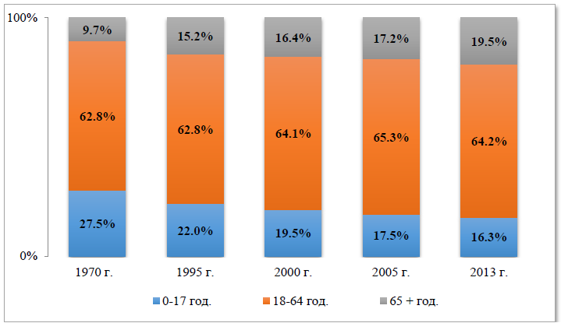
Source: Ministry of Health, National Center of Public Health and Analyses (NCPHA), Quick Reference Guide “Health 2014”

The share of persons aged 65 or older was 9.7% in 1970, while in 2013 it was 19.5% of the population. For persons aged from 0 to 17 these figures are 25.5% and 16.3% of the population respectively.
The process of demographic aging is significantly more evident for rural population (in 2013 26.2% of residents are older than 65 years) than for urban population (in 2013 17.2% of residents are older than 65 years).

It is expected that by 2050 the population of Bulgaria will decrease to 5.9 million, according to Eurostat, and to 5.5 million, according to projections of the Population Division of the UN. This decline is paralleled by major changes in the age structure of the population driven by changes in fertility, mortality and migration. The graphical representation of the population of Bulgaria was a pyramid in 1950, a sphere in 2010 and in 2050 it is expected to be an inverted pyramid. (Fig. 2)

Fig. 2 Age pyramid of the Bulgarian population

Source: World Bank Report - “Mitigating the economic impact of an aging population: options for Bulgaria”

The process of demographic aging adversely affects:
    - the reproduction of the population;
    - the number of the working age population;
    - costs for health care and social support.
The aging population will affect the demand for key public services and long-term care. Older people seek health care more often as illness, chronic illnesses and hospital visits become more frequent with age. With an aging population it can be expected that public spending on healthcare and long-term care will grow.

Birth rate

From 1970 to 1995 there is a sustained declining trend for the birth rate in Bulgaria (Fig. 3) - from 16.3 to 8.6 per 1000 inhabitants, due to the negative impact of a number of socio-economic and demographic factors. After a short period of increase, in recent years there is again a tendency for its decrease.

Fig. 3 Birth rate in Bulgaria and the EU (per 1000 people)

Source: WHO, Regional Office for Europe. European health for all database (HFA-DB)

In 2012, the total birth rate was 9.46 ‰ and it remains lower than that of the EU (10.27 ‰), but close to the level in most European countries.
Two other positive phenomena in recent years also deserve attention: the increase of the number of births and the decrease of the number of abortions per 1,000 women of fertile age (Table 2 and Fig. 4).

Table 2 Births and abortions per 1,000 women of fertile age (15-49 years)
Years | Births per 1,000 women of fertile age | Abortions per 1,000 women of fertile age
1980 | 60,4 | 72,9
1990 | 49,2 | 67,2
1995 | 35,2 | 47,2
2000 | 37,0 | 30,6
2005 | 38,2 | 22,3
2013 | 41,6 | 18,3

Source: Ministry of Health, National Center of Public Health and Analyses (NCPHA), Quick Reference Guide “Health 2014”

Fig. 4 Births and abortions per 1,000 women of fertile age (15-49 years)
Source: Ministry of Health, National Center of Public Health and Analyses (NCPHA), Quick Reference Guide “Health 2014”

The reduction in birth rate and the increase in mortality which continued for several decades led to the negative natural growth whose values have been within (- 5) per 1,000 inhabitants since 2000. (Fig. 5)

Fig. 5 Birth rate, mortality and natural growth per 1,000 people
Source: Ministry of Health, National Center of Public Health and Analyses (NCPHA), Quick Reference Guide “Health 2014”

This, together with the high level of immigration in recent years, causes serious changes in the age structure of the population which are reflected in the demographic aging of the nation, i.e. increase in the absolute number and share of the older population. Older people are carriers of more than one chronic disease (average 3.2 on a person aged older than 65) and therefore, demographic aging significantly changes the structure of health needs of the nation and makes certain requirements to their satisfaction.
The bad demographic characteristics adversely affect the expected average life expectancy, which is considered one of the synthetic indicators for the health of populations (Table 3 and Fig. 6).

Table 3. Average life expectancy of future life
Periods | Total | Men | Women
1935-1939 | 51,75 | 50,98 | 52,56
1960-1963 | 69,59 | 67,82 | 71,35
1989-1991 | 71,22 | 68,02 | 74,66
2003-2005 | 72,60 | 69,00 | 76,30
2011-2013 | 74,45 | 71,02 | 78,01

Source: Ministry of Health, National Center of Public Health and Analyses (NCPHA), Quick Reference Guide “Health 2014”

Fig. 6 Average life expectancy of future life in Bulgaria (in years)
Source: Ministry of Health, National Center of Public Health and Analyses (NCPHA), Quick Reference Guide “Health 2014”

Despite its significant increase in average life expectancy in our country falls behind significantly from the average in the European Union, where in 2013 it was 80.33 years, according to WHO / Europe, HFA Database (Fig. 7).

Fig. 7 Dynamics of the expected average life expectancy at birth (in years) in Bulgaria and selected groups of countries in Europe (15 pcs.)
Source: Ministry of Health, National Center of Public Health and Analyses (NCPHA), Quick Reference Guide “Health 2014”

Mortality
The mortality rate is a basic indicator of the population’s health status. The following health statistics facts should be addressed from this perspective:
- Increase of the general mortality rate from 9.1 per 1000 (citizens) in 1970 to 14.4 per 1000 in 2013. According to the indicator “general mortality rate”, Bulgaria is the last among all countries in the European Union (the average number for EU in 2012 was 9.7 per 1000 citizens).
- There is greater mortality rate associated with men (in 2013 the indicator “dead men per 100 dead women” was 111) – this is a fact known as “excess mortality among the male population”
- There is greater mortality among people in villages (20.5 per 1000) than among people living in the cities (12.1 per 1000 residents) in 2013.
The causes of death for more than two decades have a comparatively stable structure.
In 2013 about 65.1 % had illnesses related to blood circulation. The second cause for death are tumours (17.5 %), followed by illnesses related to the digestive system (3.5 %), respiratory diseases (3.4 %) and external causes (including incidents, self-harms, etc.) – 2.7 %, i.e. about 92 % of deaths in Bulgaria are caused by the specified five groups of causes (Fig. 8).

Fig. 8 Mortality rate structure by death causes in 2013
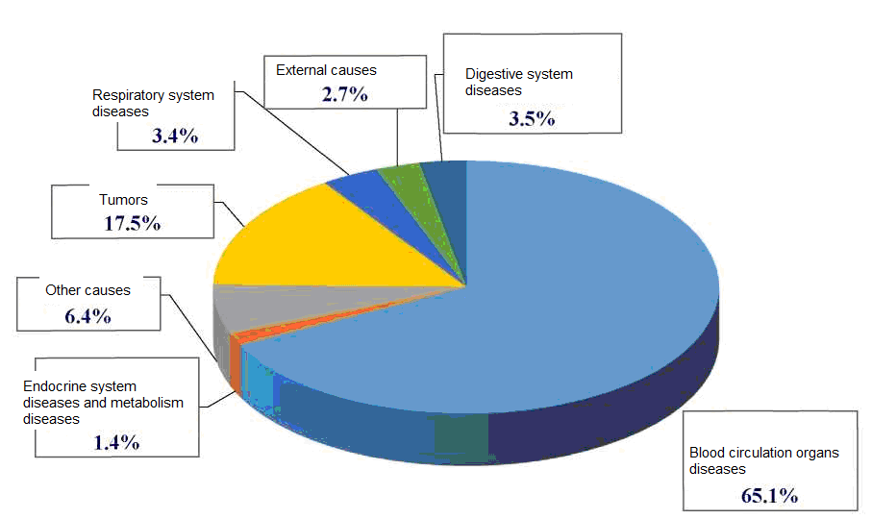
Source: Ministry of Health, NPHAC – Brief Reference Book – Health Care 2014

The high mortality rate is formed mainly by deaths of persons older than 65 years of age. The main reason for this is the aging of Bulgarian population. Demographic forecasts show that namely due to the objective aging processes the level of general mortality in the country will remain high and unchanged until 2030.
The indicator of premature mortality (relative share of dead people below 65 years of age regarding the total number of deaths) had the same level during the last 5 years and had a slight increase by 0.1 during the last year. In 2013 it was 22.4% and in 2012 it was 22.3%, i.e. almost every fourth death in the country was associated with a person younger than 65 years of age. In the case of men the premature mortality was 2 times higher (29.8% for men and 14.2% for women).
It should be emphasized that Bulgaria has still one of the highest standardized mortality rates (932.87 %₀₀₀) among the EU countries despite the reduction trend we can see (Fig. 9). In most European countries the standardized mortality rate is lower than the average for the EU (585.93%₀₀₀).

Fig. 9 Standardized mortality rates (all causes)
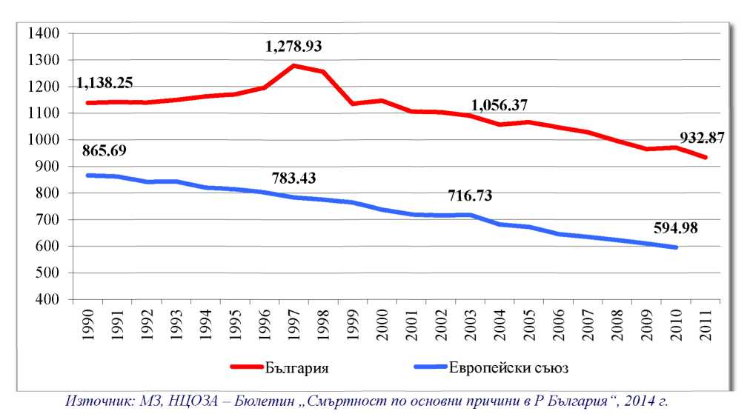
Source: Ministry of Health, NPHAC – Mortality and Main Causes in the Republic of Bulgaria, 2014

The analysis of data shows that during the last decade in Bulgaria annually some 70,000-75,000 people died due to blood circulation organ illnesses. 16,000 to 18,000 people died due to malignant tumours. (Fig. 10)

Fig. 10 Standardized mortality rates related to blood circulation organs (per 100,000 people)
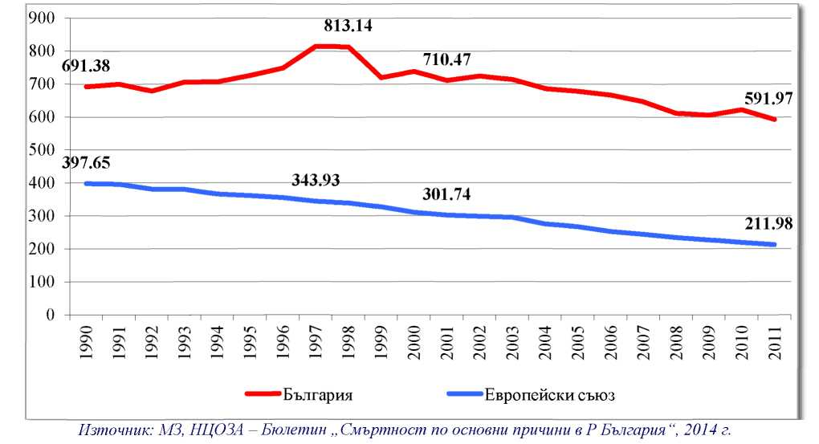
Source: Ministry of Health, NPHAC – Mortality and Main Causes in the Republic of Bulgaria, 2014

Data shows that despite the significant decrease related to the indicator in recent years the standardized mortality rate regarding heart diseases was 2 times higher than the average European values and much higher than in the developed European countries.
The careful analysis related to mortality rate dynamics shows trends which might be related to certain health policies and introduced changes in the health system which are directly related to the achieved results.
Fig. 11 shows the dynamics in the standardized mortality rate related to ischemic heart disease and we can see almost twofold decrease of the indicator regarding a 10-year period – from 2002 to 2011. This is related to the intensive development of invasive cardiology structures in Bulgaria.

Fig. 11 Standardized mortality rates related to ischemic heart disease (per 100,000 people)
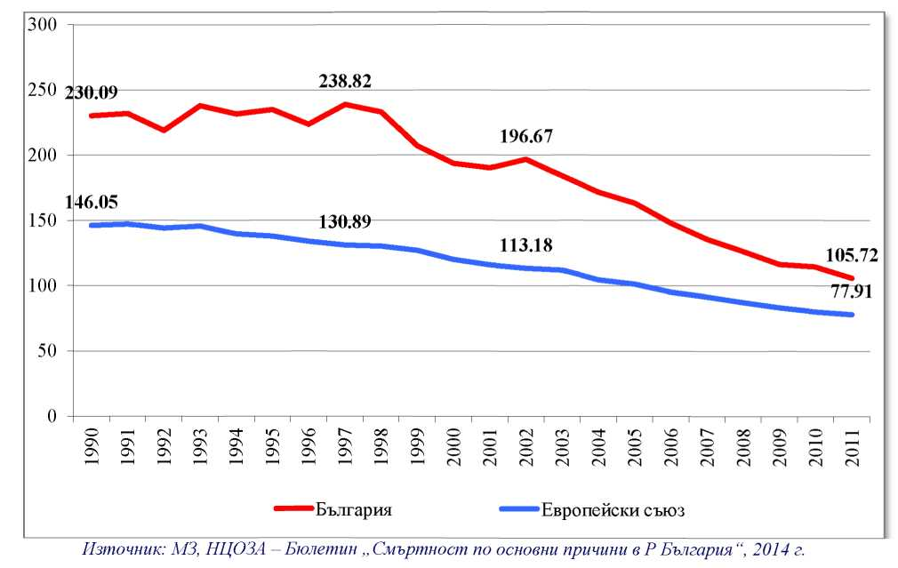
Source: Ministry of Health, NPHAC – Mortality and Main Causes in the Republic of Bulgaria, 2014

Data clearly shows how investment in effective advanced technologies can bring significant health results, comparable to the reduction in mortality rates associated with certain diseases.
During the same period the standardized mortality rate related to brain-vascular diseases showed minimum decrease with no specified trend for decrease of the difference in view of average indicators in the EU (Fig. 12). One of the possible reasons for this is the absence of specific policies related to the improvement of the potential for conservative and intervention treatment of brain-vascular diseases.

Fig. 12 Standardized mortality rates related to brain-vascular disease
(per 100,000 people)
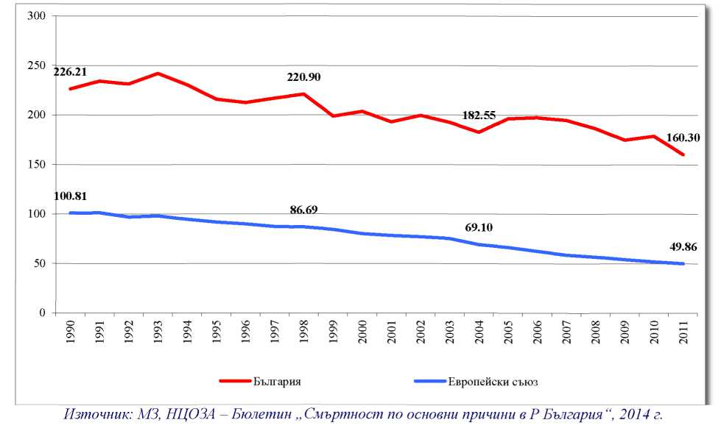
Source: Ministry of Health, NPHAC – Mortality and Main Causes in the Republic of Bulgaria, 2014

We can see some positive trends regarding the health indicator due to active health policy in relation to the opportunities to diagnose and treat malignant diseases in Fig. 13.

Fig. 13 Standardized mortality rates related to malignant tumours (per 100,000 people)
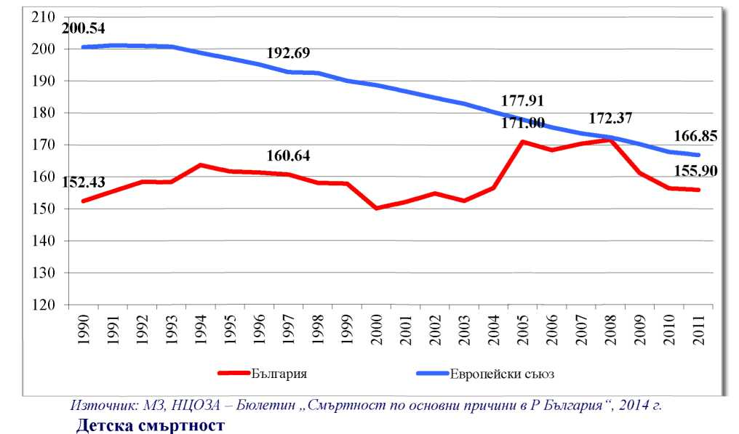
Source: Ministry of Health, NPHAC – Mortality and Main Causes in the Republic of Bulgaria, 2014

Child Mortality
Although child mortality during the last 24 years decreased more than two times – from 14.8 in 1990 to 7.3 in 2013 (per 1000 born-alive children), international comparisons show that it is still unjustifiably high (Fig. 14).
In 2013 among the countries in the European Union in view of this indicator, only Romania was in a less favourable situation (the average indicator for the countries in the European Union in 2011 was 4 per 1000 born-alive children).

Fig. 14 Child mortality rate (average indicator) in Bulgaria and the European Union
(per 1000 born-alive children)
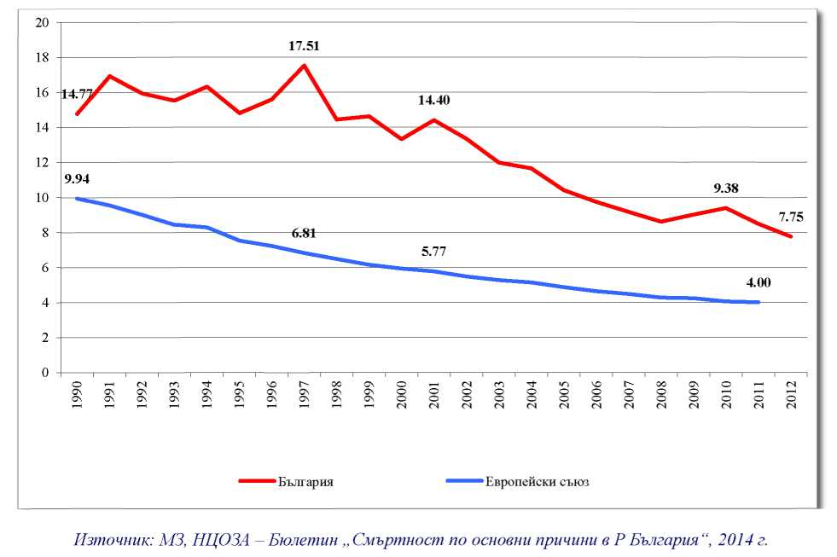
Source: Ministry of Health, NPHAC – Mortality and Main Causes in the Republic of Bulgaria, 2014

Child mortality rate is one of the basic indicators for the quality of medical services but it is also influenced by the living standards and the health culture of the population (Table 4). The regions with the highest child mortality rate are Lovech (16.5%₀), Shumen (12.9%₀), Sliven (12.8%₀), Pazardzhik (11.1%₀); the lowest values are in Targovishte (2.7%₀), Varna (4.2%₀) and Sofia City (4.7%₀). In villages the indicator remains higher than in cities (respectively 9.3%₀ и 6.7%₀). The causes for this can be found in the aggravation of social and economic conditions in villages, the limited access to health services, lower education and culture levels.

Table. 4 Children younger than one year of age (per 1000 born-alive children)
Year | Total | Cities | Villages
1980 | 20.2 | 18 | 24.9
1990 | 14.8 | 13.8 | 17.1
2000 | 13.3 | 12.4 | 15.5
2013 | 7.3 | 6.7 | 9.3
Source: Ministry of Health, NPHAC – Brief Reference Book – Health Care 2014
The analysis of child mortality by age groups shows that starting in 1980 and until present this factor is associated with constant decrease regarding the three basic indicators:
prenatal, neonatal and post-neonatal child mortality rates. However, regardless of this, these are significantly higher than the average ones for the countries in the European Union (Table 5 and Fig. 15).

Table 5 Prenatal, neonatal and post-neonatal child mortality rates
(per 1000 born-alive children)
Year  Indicators | 1980 | 1990 | 1995 | 2000 | 2005 | 2013 | Average for the EU  (2013)
Prenatal | 15 | 11.1 | 11.8 | 12.2 | 12.0 | 10.3 | 6.12
Neonatal | 10.4 | 7.7 | 7.8 | 7.5 | 6.2 | 4.2 | 2.7
Post-neonatal | 10 | 7.1 | 7.1 | 5.9 | 4.2 | 3.1 | 1.34
Source: Ministry of Health, NPHAC – Brief Reference Book – Health Care 2013 and WHO, HFA Database, June 2006

Fig. 15 Prenatal, neonatal and post-neonatal child mortality rates in Bulgarian during the period 1980-2013 and in countries of the EU (per 1000 born-alive children)
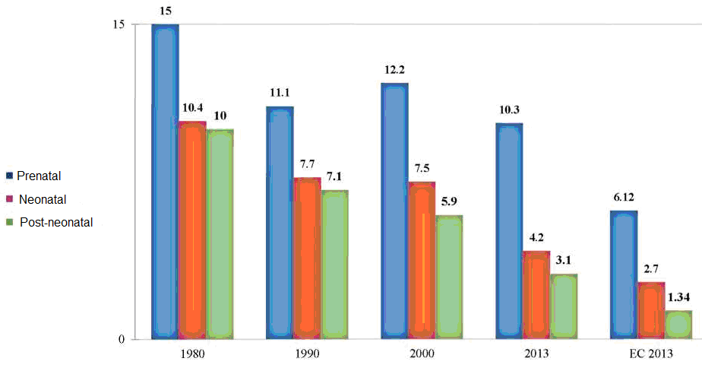

Source: Ministry of Health, NPHAC – Brief Reference Book – Health Care 2013 and WHO, HFA Database, June 2006

The analysis of death causes related to children up to one year of age (Fig. 15) shows that the largest number of the dead children is associated with “Some conditions which emerge during the prenatal period” – 231 (47.24%). We have innate anomalies, deformations and chromosome aberrations – 94 (19.22%), respiratory diseases (10.84%) and blood circulation organs diseases (10.02%). These 4 classes of diseases form 87.32% of all deaths related to children up to one year of age. We do not see significant difference in the structure of deaths for children up to one year of age in terms of gender.

Fig. 15 Death causes related to children up to 1 year of age in 2013
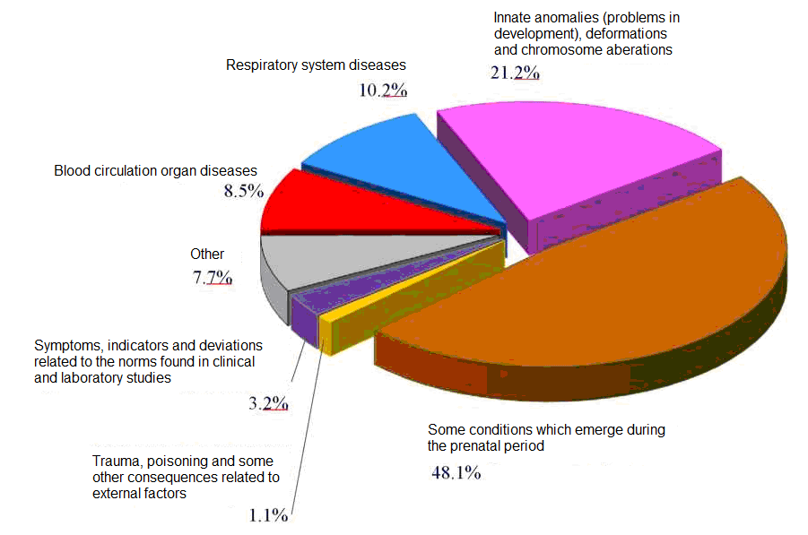
Source: Ministry of Health, NPHAC – Mortality and Main Causes in the Republic of Bulgaria (bulletin), 2014

The integration indicator characterizing the possibility of a child’s death before reaching 5 years of age in Bulgaria is 10.22%₀ – 2 times higher than the average value for the European Union (4.78%₀). The most frequent caused for death of children up to 5 years of age are the following: some conditions which emerge during the prenatal period, innate anomalies, respiratory system diseases, blood circulation organs and external disease factors.
Prematurely born children are very much related to the quality of maternity nurse services. In 2013 the number of prematurely born children was 5,848; this represented 8.8% of born-alive children. The prematurely born and dead children were 338; this is 70.0% of dead-born children. Premature birth is an important factor and has a significant contribution to the level of prenatal child mortality rates.
The mortality rate related to mothers (per 100,000 born-alive children) was 19.07 in 2001 and 12.0 in 2013. The respective EU indicator was 5.05%₀₀₀.

Permanently reduced work potential / type and level of damage
According to data from the information system associated with permanently reduced work potential for persons older than 16 years of age (National Public Health and Analyses Centre, NPHAC), based on the annual processing of expert decisions issued by LEDC and NEDC, the number of persons with primarily specified permanent reduction of work potential /type and level of damage for persons older than 16 years of age during the recent years is going down but in 2013 we could see certain increase and the number was 68,887 people. According to changes in the Law on Health, effective since the beginning of 2005, the permanent work potential reduction for persons who reached 65 years of age was specified for life. After 2008 there was dynamic and increase of the number of persons with permanently reduced work potential for life and the number of people in 2013 was 44,141 (23.5% of all certified and re-certified persons).
The greatest number and share is related to persons with a period of permanently reduced work potential /type and level of damage: 3 years (68,968 persons or 36.7% of those with permanently reduced work potential/type and level of harm). The decrease is seen also in the share of persons with permanently reduced work potential /type and level of damage with period of 1 and 2 years.
The number of certified and re-certified persons with permanently reduced work potential /type and level of damage in 2013 was 187,949 persons; there was almost even distribution among men and women. The highest relative share was the share of persons older than 60 years of age (38.6%), followed by the age group 50-59 years of age (35.6%).
The relative share of certified persons older than 16 years of age with permanently reduced work potential (71-90%) was increased in comparison with the previous year and was the highest (32.2%). Then we have the persons with 50-70% permanently reduced work potential – 31.2% and 31.8% in 2012. Every fourth person with permanently reduced work potential older than 16 years of age had 90% permanently reduced work potential – 23.2% (23.7% in 2012) and up to 50% had 11.7% (12.1% in 2012).

Fig. 16 Diseases which were the most frequent cause for permanently reduced work potential in the work place (persons older than 16 years of age)
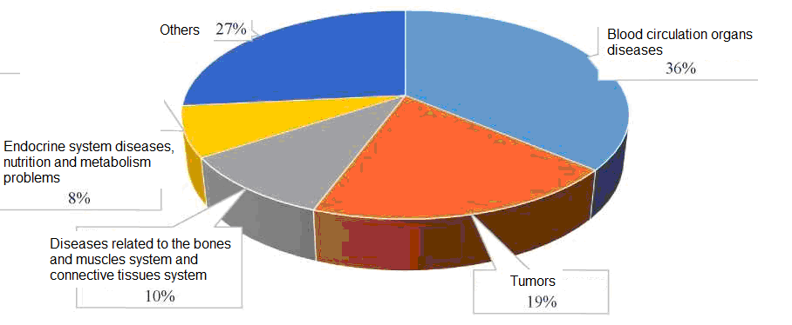
Source: Ministry of Health, NPHAC – Disability in the Republic of Bulgaria (bulletin), 2014

The most frequent reason for permanently reduced work potential for persons older than 16 were diseases related to blood circulation organs; these were 36.3% of the total number of cases related to newly certified disables persons (Fig. 16).
Then we have tumours (19.3%), bone and muscle system and connective tissue diseases (10.0%), endocrine system diseases, nutrition and metabolism irregularities (7.8%), etc. This structure /with some very slight variations/ was preserved during the last 10 years.
After 2008 we had increase in the number of certified children up to 16 years of age with acknowledged type and level of damage who in 2013 were 5,405 (4,566 in the year 2012) or 5.1 per 1000 people of the population (up to 16 years of age, 4.4%₀ in 2012). The greatest number and share of children with level of damage 50-70% was 2,514 (46.5%). Every fifth child had level of damage 71-90% (17.9%); the worst level was more than 90% (for 11.4% of the children).
The structure and causes related to the type and level of damages for children was different from the one in persons older than 16 years of age. The most frequent cause was respiratory system diseases (29.2%), nervous system diseases (16.3%), psychic and behavioural disorders (15.2%) and built-in anomalies (15.8%). This structure was preserved during the years (Fig. 17).

Fig. 17 Diseases which were the most frequent cause for permanently reduced work potential for persons younger than 16 years of age
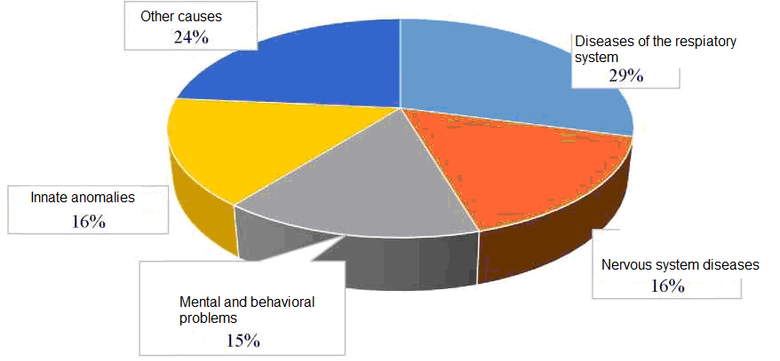
Source: Ministry of Health, NPHAC – Disability in the Republic of Bulgaria (bulletin), 2014

Data related to the frequency and structure of reasons leading to permanently reduced work potential / type and level of damage for Bulgarian citizens show permanently negative trends which should be interpreted in the context of the generally aggravated health status of the population and the quality of timely prophylactics, diagnostics and treatment and also in terms of the normative regulation of the scope of medical expertise regarding the work potential of different work groups.

Mental Disorders
Mental disorders are second in terms of contribution to disease proliferation (measured through the indicator “years of life being sick or disabled) in the European region (19%) and represent the most important disability factor.
In Bulgaria the number of mentally ill persons under supervision in psychiatric institutions went down from 1981.7%₀₀₀ in 2012 to 1442.03%₀₀₀ in 2013; these are mainly persons with mental backwardness, schizophrenia, affective mental disorder, etc. The actual number of persons with mental diseases was probably greater due to the absence of a general information system by which we could have registration and monitoring of these persons after they left the medical institutions or after they were first diagnosed with regard to external medical facilities and also in terms of the regulatory framework which has to guarantee these activities.
The studies of the WHO show that for 25-30% of initial contacts with the health-services network we see some mental disease. In Bulgaria, according to an epidemiological study of potential for mental diseases, 19.5% of Bulgarian people, during a certain stage in their life, suffered some mental disorder.
The most wide-spread mental disorder is the anxiety disorder (11.4%); the group of people affected the most by this disorder is the age group between 50 and 64 years of age (13.2%). Mood disorders (6.2%) come second and these are seen most often in the group of people older than 65 (9.1%). Disorders caused by use of psycho-active drugs (3.3%) is the third most wide-spread disorder.
The so-called serious mental disorders include schizophrenia, deep depression, organic or some other types of dementias and disorders caused by mental underdevelopment. Although their frequency remains permanent, the social and economic significance of this group of disorders increases due to problems in the individual’s social functions, leading to social isolation and some level of disability.
In 2013 the number of suicides per 100,000 people in Bulgaria was 9.44. This places Bulgaria among the countries with average to low suicide mortality rate. The frequency of suicides among women is 3.84%₀₀₀ and it is 3.7 times less than the frequency for men (14.27%₀₀₀).
Mental problems have serious consequences not only for individual people and their families but also for the development of the economy and the prosperity of society. 21.6% of days lost due to inability to work were related to mental disorders.
The problems of mental health are also a serious risk factor associated with diseases and mortality related to other illnesses. There is data that the presence of depression, for example, has a strong influence over the percentage of people with heart diseases and cancers.

MAIN CHALLENGES RELATED TO THE HEALTH OF BULGARIAN CITIZENS
The analysis of data related to the main health and demographic indicators clearly shows that presently in Bulgaria, in comparison with other countries in the European Union, faces much more serious challenges related to the following:
• High level of general mortality and premature mortality;
• High level of mortality rates associate with mothers and children;
• High level of damages and permanent inability to work;
• Low longevity in terms of total years and years with good health.
The main causes for the bad health indicators are the following:
• Chronic, non-infectious diseases, basic caused for death and reduced work potential, greatest relative share of heart diseases and malignant tumours;
• Conditions which emerged during the period of pregnancy, giving birth and the period after this; prenatal period innate anomalies.
The non-satisfactory results related to the policies realized so far with regard to the aggravated demographic state and presence of significant social risks for large groups of the population brings the necessity to have total change in the approaches associated with health services and prosperity for Bulgaria citizens.
The national health policy should be directed to the creation of effective mechanisms for overcoming health inequality related to Bulgarian citizens and reaching the highest health standards in the countries of the European Union.
The successful realization of this policy requires the following:
• clear goals;
• strong political commitment;
• prioritization of resources related to solving main health problems;
• effective health system with orientation toward the health system needs;
• public health programs with good results;
• public consensus and bringing all stakeholders related to the improvement of health processes.
This means joining efforts, goals and priorities; coordination and mutual adding of resources which the country and the society can provide; by this we will have not only stopping of negative trends in the demographic and health status of the population but we will have also creation of conditions for its steady improvement.

VISION FOR THE DEVELOPMENT OF HEALTH SERVICES IN BULGARIA UNTIL THE YEAR 2020

In 2020 Bulgaria should be country guaranteeing its citizens improvement of health and prosperity and decrease in terms of health-care inequality through a comprehensive and fair health system providing high quality of services.

MAIN VALUES:
The present concept of “Health Target Goals 2020” is based on values in the constitution of the WHO and common values and principles related to the management of European health systems in the countries of the European Union.
Acknowledging the right of every Bulgarian citizen to have high health-care standard, it is an expression of political will related to bringing a universal reach, solidarity and equal access to high-quality health services as values associated with the organization and financing of the health system:
■ Universal reach – provision of access to health services for all citizens;
■ Solidarity – provision of health expenses associated with the potential for payment and use of services by all people who need these;
■ Equality – equal access to health care in compliance with the needs and regardless of ethnic origin, gender, age, social status or wealth
■ Access to high-quality care – provision of the highest level of care and with patient orientation in terms of individual needs and on the basis of ethics and evidence.
The concept reflects the understanding that provision of fairness and equality with regard to health care, rights and obligations for provision of the highest level of individual and public health is the main prerequisite for reaching stable development and better quality of life and prosperity for everybody.
Defending these values will provide the necessary basis for the formation of national health care policy with orientation towards clear goals and results guaranteeing the rights of every Bulgarian citizen to have the highest level of health care and prosperity throughout their entire life.

NATIONAL HEALTH GOALS
On the basis of the population’s health status in Bulgaria, we have specification of the following national goals until the year 2020:
1. Reduction of mortality rates for children 0-1 years of age – to 6.8 per 1000 born-alive;
2. Reduction of the mortality rate for children from 1-9 years of age – to 0.24 per 1000 children;
3. Reduction of the mortality rate to 0.28 per 1000 in the case of young people 10-19 years old;
4. Increase of the work potential and reduction of mortality rates for persons in economically active groups 20-65 years old to 4.19 per 1000;
5. Increase of the average longevity of people older than 65 to 16.4 years;
The indicated health goals are directly related to the established problems and negative trends with regard to the health of Bulgarian citizens and provide opportunity for objective assessment of the integrated policies for their realization.

MAIN PRIORITIES:
In order to achieve the specified health goals the following priorities are specified:
1. Provision of financial stability for the health care system;
2. Change in the operation of the health care system by providing quality and results and achieving national health care goals
3. Active approach for care and creation of support environments for specific and vulnerable groups of the Bulgarian population;
4. Strengthening the capacity of public health;

PRIORITY 1

PROVISION OF FINANCIAL STABILITY FOR THE HEALTH CARE SYSTEM
During the recent years the health care costs present some serious problems to management institutions around the world. In many countries the relative share of the health care budget as a percentage of GDP is greater than ever. A number of health care systems cannot keep the costs constant and the financial pressure makes reaching a proper balance and social protection in the system even more difficult. The costs are specified mainly by provisions, for example of new methods for treatment and technologies and increased expectations of the population regarding the protection from health risks and access to high-quality medical services.
Considering the increasing health care costs around the world in Bulgaria we have a trend for steady increase of health care costs. During the period from 2003 to 2013 the health care costs related to the consolidated fiscal program increases 2.1 time – from 1,698,000,000 BGN to 3,540,000,000 BGN. (Fig. 18).

Fig. 18 Health care costs by CFP during the period 2003-2013
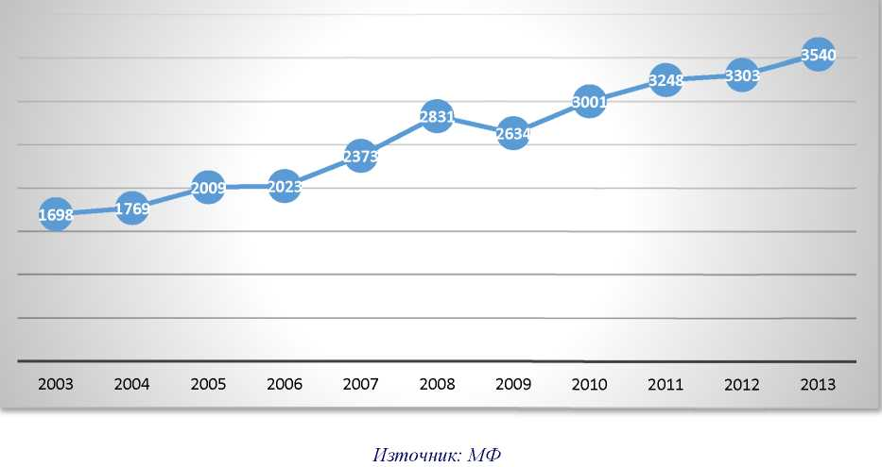
Source: Ministry of Finance

In terms of international comparisons the total costs of the Bulgarian government in relation to GDP (costs effort) and total revenues related to GDP (revenues effort) were slightly more than the average values in comparison with other countries with similar revenues. Between 1995 and 2012 the government increases the share of the budget used for health care from 8.5 to almost 12 percent. In comparison with countries with similar revenues, this is slightly more than average values and shows that Bulgaria gives a slightly higher priority to health care as a share of the budget.
At the same time sociological studies of households budgets in Bulgaria shows that the high level of payments significantly limits the financial protection of everybody. The share of the households budgets used for health care is comparatively high – 5.3 percent in 2013; it was about 3% in Western Europe (average values).
The average cost related to health care for a Bulgarian household, using NSI data in 2013 was 553 BGN and for a single person the figure was 223 BGN. (Fig. 19).

Fig. 19 Average cost in BGN per household and per person for health care
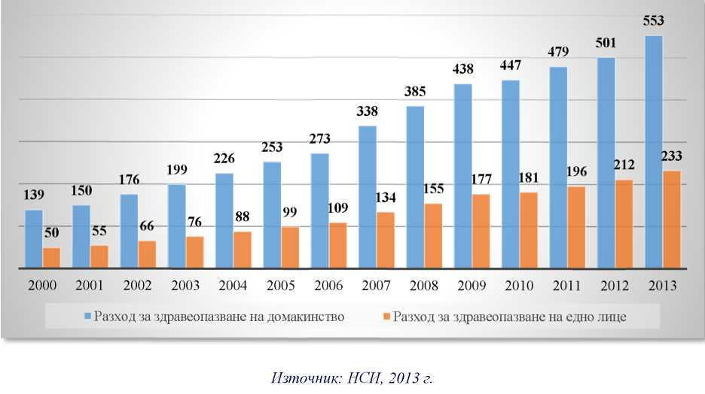
Costs for health care per household | Costs for health care per person
Source: National Statistics Institute, 2013

The analysis of dynamics related to health care costs and health/demographic indicators for the population show clearly that the steady increase of health care funds does not bring the respective improvement of indicators related to wellbeing of citizens.
On the other hand, the aggravated health and demographic indicators and social-economic environment bring the increase of pressure over the financial stability of the health care system. Fr the year 2050 we have a forecast that every third person will be aged 65 and older and only every second Bulgarian will be in an age fit for work. The forecasts of the UN are for net migration values of 10,000 persons per year until 2050; the forecasts of Eurostat are for even greater cumulative loss. Therefore until the year 2050 the ratio of old age and dependability will be expected to double i.e. 50; the forecasts for provision of workforce assume reduction by up to 40%.
These types of pressure are made more serious by the significant and increasing part of the population which is represented by poor people or people who are very vulnerable and endangered to fall under the poverty line; these people would, therefore, be hardly able to pay for life-support services using only their own funds. According to World Bank data, the levels of poverty increase, starting in 2008; in 2011 more than 21% of the population lived below the national poverty line; more than 16% of the population lived with 5 US dollars per day (parity purchasing power) or less and almost 4% of people lived with 2 US dollars per day or less. Almost half of the population (and 60% of the persons 65 years of age or older), however, or 3.6 million Bulgarians are subjected to the risk of poverty or social exclusion – the highest percentage in the EU.
These trends in vulnerability and the decreasing tax basis is not supported by the fact that a significant part of the workforce is engaged in the non-formal sector. Recently the “shadow economy” was valued as being more than one third of GDP and approximately 16.5% of all people working are in the non-formal sector.
According to some experts, the main trends for the demographic state of the population and the extremely high increase of costs in the health care system in combination with trends in the labor market and GDP /which mainly bring stagnation for revenues/, lead to even greater deficits in the government share related to the health care budget.
The total government costs for health care are expected to increase from 4.5% of GDP in 2013 (3,540,000,000 BGN) to 5.3% in 2020 (5,379,000 000 BGN) – this is an increase of 0.8 percentage points of GDP regarding the state share related to health care. The total government expenses related to health care will be increased from 12.1% of the government’s budget in 2013 to 13.6% of the government’s budget in 2020; this is an increase of 1.5% (1,839,000,000 BGN). This will further exacerbate the fiscal pressure over the government’s budget (Fig. 20).

Fig. 20 Forecast for revenues, expenses and deficit in the health care sector during the period 2013-2020
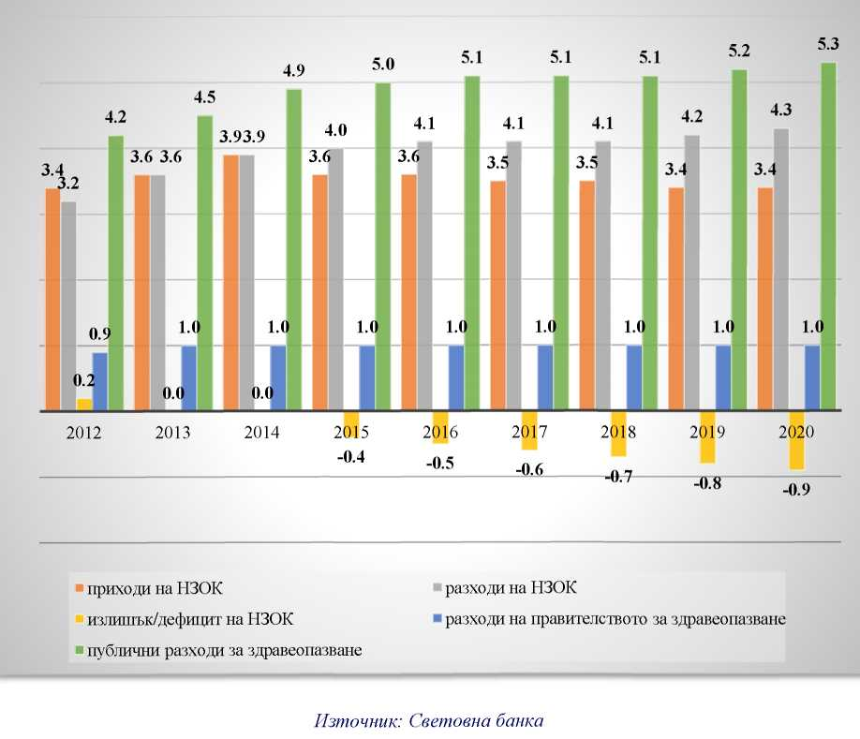
 | NHIF revenues  NHIF surplus/deficit  public health care costs |  | NHIF costs  government health care costs
Source: World Bank

The expectations of the World Bank are that costs for the NHIF (National Health Insurance Fund) to increase from 3.6% of GDP in 2013 (2,780,000,000 BGN) to 4.3% of GDP in 2020 (4,375,000,000 BGN). At the same time we have forecasts for reduction of revenues as relative share of GDP – from 3.6% of GDP (2,788,000,000 BGN) to 3.4% of GDP in 2020 (3,469,000,000 BGN), despite the absolute increase of 681,000,000 BGN. This according to the forecasts might lead to deficit in the financing of NHIF of 0.9 percent of GDP (906,000,000 BGN). This deficit will bring, all other conditions being equal, worse fiscal situation by 0.9 percent in Bulgaria after 2020.
The use of funds by NHIF will be increased by 9.5% regarding all used funds during 2013 to 11% in 2020 (Fig. 21).

Fig. 21 Forecast for revenues and costs related to NHIF during the period 2013-2020
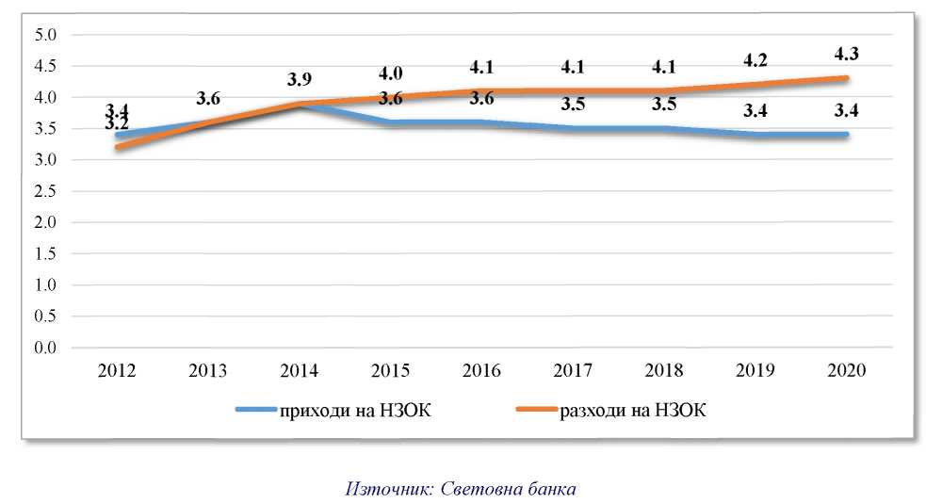
NHIF revenues | NHIF costs
Source: World Bank

“Demographic, epidemiologic and economic trends in combination with the existing structural non-efficiencies related to the present health care system present significant challenges for the future adequate financing of health care services for the population of Bulgaria..
This brought a situation where the current health care system does not meet the needs of the population. If no significant reforms were introduced, future health care and financial perspectives look grim.“
World Bank (2015)

According to international analyzers the reforms in health care in Bulgaria should be undertaken in the context of the present and possibly future macro-economic and more specifically fiscal situation. Bulgaria is similar to some other advanced and newly emerging markets and will continue to be subjected to strong pressure for increase of funds related to health care. Although a large part of this pressure is caused by internal and inherent problems of the present health care system, many of these are external with regard to the health care system and include the following: aging of population, increase of income, technical progress and health policies and institutions. The level to which Bulgaria copes with these types of pressure depends on the general fiscal factors in the country and on decisions of the government in the sphere setting the priorities in the health care sector.
A study by the IMF pointed to the insistency of this pressure in the long term with regard to the advanced and the newly emerging markets (countries). In order to meet the fiscal goals and meet the forecasted increase of public expenses during the period from 2014 to 2020 the countries will have to increase on average their primary balance (government revenues minus costs and excluding payment of interests) by 2.25 percent of GDP. IMF believes that in the case of Bulgaria, public costs for health care should be increased by 3.2 percent of GDP until 2050 in order to meet the trends related to demographic indicators and the extraordinary increase of expenses.
In terms of the fiscal environment (with some limitations), this will bring strong pressure on the government in relation to the following:
• increase of revenues;
• control of costs;
• setting priorities.
The first approach assumes increase of funds for health care by redirecting funds from other public cost sectors. We should keep in mind that the necessity to increase the revenues in the health care system is an objectively specified process which brings the question of “suitable level” of financing being set in the general context of policies for improvement of health and the value which is associated with health care, examined individually or in comparison with other spheres of public spending.
At the same time we should keep in mind the fact that the significant increase of health care costs during the recent years didn’t bring the respective improvement of indicators related to the population’s good health. This shows that if no other measures were introduced, this approach alone will not guarantee successful meeting of health care challenges.

The second approach for control of health care costs is related to the application of strategies which will have influence over the demand and supply of health care services.
Presently, the undertaken measures for control of health care services provided by the Bulgarian health care system do not give satisfactory results and cannot meet the non-stop increase of funds for health-insurance payments, especially regarding hospital care and provision of medicines. This imposes the introduction of new and effective control forms for system costs:
The introduction of upper limit values for services paid for by the NHIF in terms of the total costs and the associated components for effective management and control will limit the unfounded increase of hospital care costs. The long-term effects related to this measure include optimization of the number of hospital beds, rational restructuring of hospital services, intensification of hospital care, shorter periods of stay in hospitals, etc.
The regulation of the use of costly diagnostic and treatment technologies and the establishment of control over these will also need attention. Such control will include measures for enhanced regulation, concentration of the material base, avoiding non-controlled growth and avoiding the presence of redundant equipment.
An important measure is the payment by NHIF only for services related to technologies and medicines which have proven effect over treatment. The increase of costs related to the introduction of new technologies and medicines, the issue of their safety, public impact and problems of ethical nature present the necessity to have careful evaluation before allowing introduction in clinical practices. This will pose creation of capacity for evaluation of health care technologies in the context of efficacy and quality of health services.
The establishment of control over the behaviour of medical experts is very important. Through the introduced medical standards, diagnostics and therapeutic algorithms and good practices rules we should have enhancement of the control and payment of examinations, procedures and prescription of medicines related to a specific disease.
It is necessary however to emphasize that the control over the costs related to health care should be subjected to the understanding that it, in essence, is a method for optimization in order to reach certain health results and not only an end in itself regarding the decrease or limitation.

The third and most advisable approach is the increase of the effectiveness when using health care funds.
The increase of the effectiveness in the health care sector might bring significantly better results and might compensate the necessity of significant increase of costs. Measures for improvement of effectiveness include essential changes in the method of the system’s operation method and services provided by it, including rationalization of hospitals, strengthening the alternatives of hospital care and solving the problem of limiting human resources by using financial factors and other incentives necessary for keeping qualified health care employees in the Republic of Bulgaria.
The effective use of funds related to health care poses regrouping of financial resources:
• by health care packages;
• by types of medical services – primary, specialized out-of-hospital and hospital care;
• in terms of promotions, prophylactics, screening, diagnostics and treatment;
• in terms of health-insurance individual types and insurance payments;
• on the basis of results and medical care quality.
Special attention should be directed toward the specification of high-priority health services in order to have rational distribution of funds for their financing.
During the last several years we had increase of empirical views on the tools used by NHIF and professional organizations for the determination of high-priority health care services. In general, this shows that the application of well considered approaches for specification of priorities will play a positive role not only now but also during the years to come.
The specification of high-priority health care services is based on the necessity to concentrate the resources for establishment of activities with associated intervention in the very health problems of the population and the improvement of the population’s health indicators.
The mechanisms for payment of health care services which are presently effective through the system for mandatory health insurance do not allow setting priorities and direction of system resources (financial, human, infrastructural, etc.) to the important health issues. It is necessary that these were examined in the context of the specified national health goals (Fig. 22) through the introduction of the following:
• Basic package of health care services paid for by NHIF, aimed at prophylactics, diagnostics and treatment of the main diseases and conditions leading to death and loss of the ability to work; issues related to the health of children and mothers;
• Additional package of health care services paid for by NHIF, allowing planning through a waiting list;
• Urgency package of health care services paid for by the Ministry of Health;
The division of the package of health care services paid for by NHIF is not related to a principle change in the health insurance model but has to specify the medical services bought by NHIF, depending on the social importance of diseases and optimal time for their treatment.
The main and additional package of health services will be paid for by NHIF; the activities related to the main package will be brought to a minimum; in terms of the planned activities related to the additional package we will have creation of standardized mechanisms for planning within certain limits and preparation of a waiting list for patients. People with health insurance who do not want to wait for medical services who are included in the additional package will be able to receive the respective health care service through a contract for medical insurance with an insurance company selected by them.
Children, pregnant women and mothers will receive service with high priority within the basic package of health care services.
The package of health care services associated with urgency will be covered by the state budget and by this every Bulgarian citizen will be guaranteed timely and equal access to medical services in cases with urgency.
The key decisions related to the specification of high-priority health care services will be subjected to regular review due to the dynamic nature of health care processes and medical activities.

Fig. 22 Restructuring of the health care services package
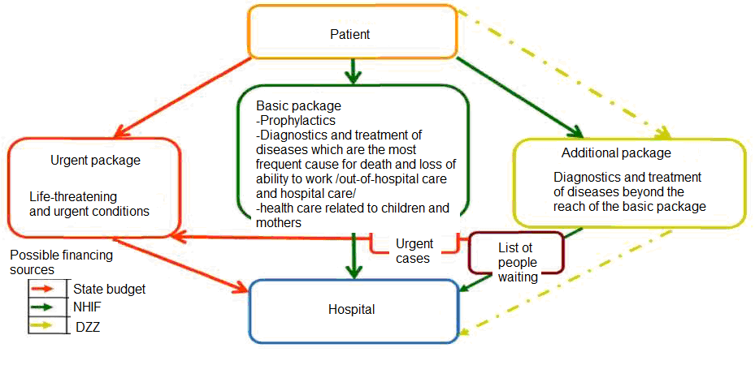
Important element of the overall policy for improvement of the health care system’s effectiveness is the adequate medicines policy directed toward quality, safety and efficacy for all medicines; sufficient availability and accessibility for the basic medical products; prescription and use of medicines with good reputation related to therapeutic practices and effective medical properties.
In order to limit the unfounded increase of costs for medicines during the recent years we foresee different mechanisms:
reimbursement policy oriented toward the goals
pro-generic medicines policy;
use of innovative medicines with ensured financial stability and predictability on the basis of needs and proven effectiveness;
Evaluation of health care technologies, etc.
The expected results related to the realization of the stipulated measures are provision of high-quality and accessible medicines, effective and rational use of public funds and guaranteeing financial stability.

Basic activities for realization of goals:

Provision of financial stability of the health care system including:
• Steady increase of the health care funds as a percentage of GDP;
• Accepting standards for financing of health care activities which are covered by the state with guarantees for effective and oriented toward good results use of funds from the national budget;
• Improvement of the revenues related to health insurance by increasing the collection potential for health insurance payments and step-by-step increase of payments related to health insurance payments for persons covered by the state;
• Creation of incentives for development of voluntary health insurance;
• Use of funds from European funds and other international funds for the financing of activities related to the health care system;
• Use of public-private partnerships for the health care system financing on the basis of projects where the leading criterion if the public interest.

Effective use of the financial resources for satisfying the needs of the population related to high-quality and accessible medical aid:
• Restructuring of the health care package paid for by NHIF and regulation of the following:
- basic package of health care services aimed at prophylactics, diagnostics and treatment of basic illnesses and conditions leading to death and loss of ability to work with regard to out-of-hospital and hospital care and health care related to children and mothers;
- additional package of health care services allowing planning of resources guaranteed by the health insurance system and other sources; regulation of an urgent package of activities paid for by the national budget in relation to out-of-hospital aid and hospital aid;
• Improvement of mechanisms related to pricing and financing of medical activities, including regulation of the “price of labour” related to medical experts which can be included as an element in the price of activities;
• Improvement of mechanisms related to pricing and reimbursement of medicines and medical products paid by public resources;
• Introduction of mechanism and criteria for selection of medical service contractors which will be paid using public resources in order to guarantee coverage of the population’s needs with regard to high-quality medical aid;
• Binding financing with the evaluation of the quality of medical services and patient satisfaction.

Creation of financial mechanisms for restructuring of the health care system and its adaptation to the needs of the population regarding medical services through the following:
• Improvement of the structure of costs by types of medical aid with step-by-step increase of funds and the relative share of costs for primary and specialized out-of-hospital medical aid and reduction of costs related to medical care in hospitals and medicines;
• Creation of financial models and mechanisms for redirection of funds toward new forms of patient service – one-day treatment, one-day surgery, long-term care, continuous care and palliative care;
• Redirection of additional financial resources, providing extension of the volume of activities realized with regard to primary medical care.

Increase of the effectiveness of treatment by medicines in order to improve the quality of life for patients and reduce the treatment costs through the following:
• Introduction of mechanisms for evaluation of health care technologies with regard to the realization of the policy related to medicines;
• Introduction of mandatory centralized negotiation for rebates related to medicines, applicable for treatment of malignant tumours, medical products for home use and medicines which NHIF pays for with regard to the realization of national programs using funds from the budget of the Ministry of Health in order to reduce the costs of NHIF;
• Creation of a mechanism for rebates negotiation when medicines are included in the positive list of medical products which increase the costs of NHIF;
• Introduction of pharmacology and therapeutic manuals, including evaluation criteria for the effectiveness of the applied therapy and recommendations for algorithms for treatment using medical products paid for with public funds; this will bring greater control and evaluation of the applied therapy.

PRIORITY 2

HEALTH SYSTEM ORIENTED TOWARDS THE MAIN HEALTH CHALLENGES

Launched in 1999, the reform of our health and the then introduced models for the organization and provision of primary, specialized outpatient and hospital services are in recent years subject to continuous change in their configuration, which represents a reflection of the changes in both their demand and the instruments of their supply and funding.
Now the pressure related to the revision of these models is driven by several factors, including - the problem of the control concerning the total cost of health services and the established tendency to search for additional resources in response to changes in the population demographic structure and increased demands of patients and medical professionals for improved quality of health care and care for the sick.
New technologies in the field of imaging, functional, endoscopic and medical laboratory diagnosis, therapeutic and surgical methods of treatment, transplantology, etc., significantly affects the structure and efficiency of the practices related to clinical and preventive medicine. On the other hand, the establishment of strict control over the utilization of funds for health services is bringing about increased scepticism in the rationality of the boundaries between different types of healthcare as outlined in the Hospitals Act and in the annual National Framework Contracts. In particular, the role of hypertrophied network of hospitals, which is increasingly being questioned, given the present organizational and professional opportunities for expansion of diagnosis and treatment on an outpatient basis. During recent years, it has become necessary to include the health services into a common approach to comprehensive care for people with medical and social problems and the development of integrated health and social services.
It is therefore imperative that the health system responds quickly and appropriately to that pressure through realignment of resources within the different types of health services and through seeking the best and most cost-effective decisions in terms of the changing patients’ health needs and requirements.
The number and type of medical institutions in the country, the available facilities and equipment, as well as the number and structure of the medical and other professionals working in these institutions must be reorganized so as to achieve better results in terms of clinical practice, funding and health services quality.
Strengthening the health system and its focus on the people’s need of quality, affordable and integrated health care is a key challenge standing before the health policy makers in the coming years.

OUTPATIENT CARE
The analysis of the health care system shows that the structures and processes in outpatient care are characterized by a lack of proper coordination between public health services and other health and social services, including health promotion, disease prevention, response in cases of acute illness, health care management and rehabilitation. There are many reasons for the poor coordination, including poor management of the health system and fragmented organization of service provision, including healthcare and social services, lack of financial incentives and financial policies conducive to effective healthcare coordination, differences in the clinical practices of physicians (general practitioners and specialists) and lack of evidence based approach to the overall consistent healthcare process.
The development of primary healthcare continues to be a major challenge in Bulgaria due to the limited profile of activities and tasks, lack of conditions for teamwork, limited recognition, weak links with higher levels of service and inadequate funding. This model is the result of distorted trends in health spending and policies that favor the intensive treatment services and high-tech diagnostics at the expense of the basic health care, disease prevention, health promotion, rehabilitation and social welfare.
Health promotion and disease prevention are essential elements of the public health, and the further development of primary health care provides a key strategic method for effectively providing these services.
The primary health care, performed by trained GPs and other healthcare professionals, is an essential tool for addressing the challenges facing our health care system.
It should develop its capacity to provide services for health promotion and disease prevention and to act as a hub for connecting to other forms of care. We have to build a coordinated approach to healthcare that promotes a balanced system of public, including social services, health promotion, disease prevention and specialized outpatient and hospital care.
Such integrated health and social approaches and services will be able to most effectively answer the needs of patients in maintenance treatment, general and / or special health care, domestic health care and social rehabilitation in an outpatient or home environment and will considerably reduce their needs for admission to hospitals of active treatment. Thus primary care will be able to respond to modern needs by creating an environment to develop partnerships and encourage patients to participate in treatment in new ways and to take better care of their health.
The most distinctive features of an effective primary healthcare targeted at people, which should be built in Bulgaria, include focusing on health needs; maintaining personalized relationships through care coordinators who use approaches to chronic care case management; taking responsibility for health and lifelong health determinants, and integrating people as partners in the management of their health problems.
Achieving this goal requires not only reforming the provision of services, but also complying the solutions with health financing, to ensure appropriate allocation of resources within the health sector, reforms in public policy to ensure the involvement of other public sectors, and the people themselves to protect public and individual health.

Main activities for implementation of the objectives:
➢ Improving the structure, organization and financing of primary health care
• Expanding the functions and activities carried out in primary health care; improving the system of payment for primary health care in which to increase the share of payment per activity;
• Improving the mechanisms of planning and defining the activities of general practitioners in order to avoid limiting the diagnostic and therapeutic activity of general practitioners;
• Establishing mechanisms to provide the population with equal access to primary health care;
• Improving the organizational model of work in primary health care in order to ensure timely access of the population, outside emergency cases.

➢ Improving the quality of primary health care
• Creating incentives for specialization in general medicine tailored to the characteristics of the workflow in medical establishments for primary health care;
• Putting into practice the guidelines of conduct for general practitioners in major diseases leading to death and disability; maternal and child health care;
• Improving the methodology and criteria for accreditation of medical institutions for primary health care in order to ensure quality in the conduct of activities in providing primary health care and education.

➢ Improving coordination and interaction of primary health care with other sectors of the health care system and social care
• Creating prerequisites for functional and structural unification of the medical establishments for primary health care, both among themselves and within the hospitals for specialized care;
• Improving regulations on coordination and interaction between medical establishments for primary health care and the emergency medical care system and the structures of specialized outpatient and hospital care;
• Developing integrated health and social services in the community

HOSPITAL CARE
The study on spending public funds in different countries shows that Bulgaria spends relatively more funds for hospital services - 52% of its current spending, nearly 20 percentage points above the proportion intended for hospitals in other countries (Fig. 23).

Fig. 23 State funding for health care in Bulgaria and EU countries
Source: OECD health and Bulgaria NHA

The hospital capacity and the proportion of hospitalizations are above average, even when comparing Bulgaria with countries of similar levels of income and health care costs. Although the number of hospital beds per 1,000 people decreased significantly compared with the peak in the 90s of last century, it remains relatively higher than the European average levels. At the same time, the number of opened new hospitals is increasing, mainly in the private sector.
As a result of the lack of effective mechanisms for planning and regulation of the capacity of hospital structures, the hospital sector in Bulgaria is characterized by a large number of hospitals and hospital beds and distorted structure of hospital beds, with prevalence of beds for active treatment.
This redundant infrastructure is accompanied by a consumption of hospital services higher than the EU average. In 2011 hospitalizations in Bulgaria were nearly 40 percent more than the ones in the more recently acceded Member States. The analysis of hospitalizations in Bulgaria prepared by the World Bank in 2013 showed that 20 percent of the inpatient procedures performed in hospitals in Bulgaria could have been performed in an outpatient setting.
At the same time, outpatient examinations are relatively fewer in Bulgaria (average of 5.5 outpatient visits per person per year in 2011), compared with an average of 7.23 visits in other countries that joined the EU after 2004. (WHO, Health for all database, 2014)
In this regard, the EU recommendation on the National Reform Programme of Bulgaria for 2014 is as follows: "To provide cost-effective provision of health services, including through improved pricing for services in healthcare in linking financing to hospitals with results, accelerating the optimization of the hospital network, and developing the options for outpatient treatment."
Rationalization of provision, efficiency and appropriateness of hospital services and the consequent reduction in the number of unnecessary hospitalizations is a key element of the reform of the organization and the structural configuration of the health system in the country.
The ultimate goal is to optimize the network of the hospitals for active treatment and reduce the number of beds in them, and, at the same time, preserve and increase their capacity to treat acute diseases, develop high-tech diagnostic and treatment services, and increase the supportive role of the system for outpatient health care, rehabilitation structures, long-term treatment, long-term health care and others.
It is appropriate to intervene in the introduction of new technologies, including endoscopic and other invasive diagnostic and therapeutic procedures, surgical procedures, medical treatment, etc., which will enable early and qualitative diagnosis and safe and effective treatment for the growing number of diseases.
It is necessary to develop criteria (indicators) for hospitalization and hospital discharge in a plan and urgency order, as well as introduce requirements and criteria for quality medical services coupled with the end result of hospital treatment as a basis for payment of hospital activities.
It is also important to improve the capacity and conditions in hospitals for long-term treatment and rehabilitation and in hospices as well, which will allow a significant percentage of patients with chronic diseases or those in need of palliative care to be hospitalized in them, rather than in expensive hospitals for active treatment.

Main activities for implementation of the objectives:

➢ Restructuring and rationalization of the hospital sector through:

• Introduction of mandatory National Health Card,
- taking into account population needs of medical care by types –according to its age structure, morbidity, prevalence, mortality, infant mortality, etc.;
- creating mandatory minimum and maximum requirements for spatial distribution of structures for outpatient, inpatient and emergency care, high-tech medical activities;
- regulating the opportunities for investment and access to public resources in the healthcare system.
• Development of models for quality assessment in medical institutions by introducing compulsory accreditation of those medical establishments for hospital care that want to use public funds;
• Encouraging the creation of hospital unions for efficient utilization of hospital resources;
• Stimulation of the process of transformation of beds for active treatment into beds for long-term treatment, and development of day surgery, day hospital treatment, ambulatory activity and others.
• Establishing a model for restructuring of hospitals with limited level of competence, including development of activities for long-term care.

➢ Introducing mechanisms for improving the quality and efficiency of patient health care:

• Creating conditions for the development of high-tech activities with guaranteed equal access of the population and efficient utilization of resources;
• Establishing a system for payment of hospital activity, based on the results of the diagnostic and treatment activities;
• Improving the control system of hospital activities based on objective criteria and indicators for assessing the quality and patient satisfaction;
• Involving professional organizations in the provision of quality patient health care;
• Improving logistics in the healthcare system by introducing rules for coordination and cooperation between medical professionals and medical institutions of emergency, primary and specialized outpatient and inpatient health care, and between the different levels of hospital care;
• Introducing specific mechanisms and approaches to providing medical care in remote and inaccessible areas.

EMERGENCY MEDICAL CARE

The emergency medical care will be developed to ensure equitable access of the population, corresponding to the best European practices and requirements for timeliness, adequacy, quality and safety. This will require improving the functioning of the system and ensuring its financial sustainability, personnel and material-technical provision.

The changes will be aimed at solving problems related to:
• the growing imbalances and inequalities in the population in terms of access to timely and quality medical care;
• the worsening staffing, insufficient training and motivation of workers;
• the disrupted integrity and coordination between emergency health care and other parts of the health care system – primary health care, specialized outpatient care, hospital care, leading to destabilization of the health system as a whole;
• the frustration and health uncertainty of the society in terms of the quality of emergency medical care;
• ensuring the security of medical teams.

We envisage the implementation of an integrated emergency service model in equal structures for outpatient and inpatient care to ensure timeliness, continuity and quality of the performed medical procedures in accordance with the Concept of the emergency medical care system development that is persistent, transparent and reaches public consensus.

Main activities for implementation of the objectives:

➢ Providing adequate and uniform spatial distribution of the emergency medical care structures
• Updating the legislation regulating the structure and organization of the integrated system for emergency medical care in accordance with the Concept of the emergency medical care system development;
• Introducing criteria for security and access of the population with structures for emergency medical care of certain levels and competence;
• Preparing and approving a Map system for emergency medical care as part of the National Health Card.

➢ Improving the infrastructure and material-technical provision system for emergency medical care
• Construction, repair, reconstruction and equipment of emergency care centers and emergency medical care hospital structures;
• Ensuring new sanitary automobiles and medical equipment for mobile medical teams;
• Improving communication and information systems of emergency health care and integration with the National Emergency Call System, a single European phone number 112. Coordinated use of TETRA system of the MI (Ministry of the Interior).

➢ Ensuring sustainable development of human resources in the system of emergency medical care
• Introducing financial incentives for working in the emergency medical care system through the gradual increase of salaries in the Emergency Medical Care Center to 100% in 2020;
• Establishing a system for the selection, ongoing training and evaluation of employees in the emergency medical care;
• Regulating the new types of personnel in the system of emergency medical care - physician assistants and paramedics;
• Establishing a training center for employees in the emergency medical care system.

➢ Ensuring the efficient organization, coordination and management of the unified system of emergency medical care
• Updating the medical standards, regulating the requirements for emergency medical care structures;
• Introducing mandatory standards and protocols for triage and behaviour in the emergency medical care system;
• Constructing a logistics center at the MH (Ministry of Health), performing coordination and management of the unified system of emergency medical care;
• Ensuring the readiness of the unified system of emergency medical care for disaster response;
• Developing the European coordination and cross-border cooperation in emergency medical care and disaster response.

➢ Ensuring financial sustainability of the system of emergency medical care
• Improving the mechanisms for managing the budgets of the Emergency Medical Care Centers;
• Improving the mechanisms for funding hospital emergency;
• Effective use of the possibilities of the operational programs for financing activities related to the development of the emergency medical care system.

HUMAN RESOURCES

The serious problems in the field of health care human resources require an active policy that can improve planning, university training, specialization and continuing education, economic and social status of workers in the health care system, and reduce the pace of internal and external migration.
The policy in the field of human resources will be implemented with the active collaboration of various institutions - ministries, professional organizations, universities, national centers, hospitals, etc., related to the development of human resources.
The basis of the activities is the application of the best practices in human resources management - planning, recruitment, training and retention of staff, tailored to the needs of medical professionals and social needs met in the EU and according to its regulations and directives.
The education and training of healthcare professionals should be reconsidered so as to improve coordination between the priorities of education and the health systems and the population health needs.
The ability to update their knowledge and skills to respond to new health challenges is a prerequisite for health professionals of the future and it must be supported from easy access to learning opportunities throughout life.
This includes the acquisition of knowledge and competencies for: providing team services, new forms of services (including domestic health care and long-term treatment), skills to promote the empowerment of the patient and the ability to care for its own health, better strategic planning, management, working with different sectors and leadership capacity.
We need a new work culture, which favors the introduction of new forms of co-operation between those working in the public health system and in health care, and between health and social workers, as well as with representatives of other sectors.
The relationship between doctors and other medical professionals and patients remains crucial and must be supported, as healthcare becomes increasingly complex and necessarily multidisciplinary.
Efficiency and productivity can also be increased by improving the process of health care through reliable approaches and health care packages; creating coherent interdisciplinary health care teams with effective management; creating curricula based on competence, reinforced by training on and outside the workplace; fair remuneration, appropriate incentives and access to the necessary resources; preventing occupational risks and increasing the role of information, feedback and evaluation.
It is important to create customizable policies, sustainable structures and capacity for active preparation and emergency response for public health, including outbreaks of infectious diseases and other disasters.
Main activities for implementation of the objectives:

➢ Providing human resources to guarantee the needs of the population of quality and affordable medical care through:
• Determining the demand for staff in the healthcare by regions, categories, specialties, depending on the health and demographic characteristics of the population;
• Developing and implementing an integrated information system for monitoring health staff as part of the national health information system;
• Establishing mechanisms for linking the admission for training of medical professionals (doctors, health care professionals and others) with identified needs and imbalances in the availability of staff in the system;
• Regulating the requirements for availability of personnel of different levels in the health system based on the criteria of equal access of the population to different types of medical care;
• Introducing economic incentives to increase interest in the training and specialization of medical specialists in areas where there is a serious shortage of staff;
• Creating conditions for expanding the functions of health care professionals, which will enable the performance of specific activities and services related to long-term health care, palliative care, etc.;
• Regulating new categories of staff in the health care system - medical assistants, paramedics and others.

➢ Improving the system of education and training, ensuring the quality of medical care through:
• Updating of curricula in high schools aimed at expanding practical skills of medical professionals with priority to major health problems and modern technologies of health activities;
• Improving the process of health care personnel specialization, including the liberalization of access to specialization and increased requirements in the training and the acquisition of specialty;
• Developing the system of continuing medical education and increasing the control and responsibility of the medical specialists professional organizations in organizing and conducting the training.
➢ Improving working conditions and compensating the health care system employees through:
• Developing a new compensation model for those employed in the health care system, linked to educational degree and performance;
• Introducing modern activity management systems to ensure healthy and safe working conditions in the health care system.

DEVELOPMENT OF ELECTRONIC HEALTH CARE

An essential tool for ensuring the effective functioning of the health care system is the ability to collect, summarize and analyze health care information. A key measure is the integration and connectivity of healthcare by building a national health care information system and ensuring public access to the system through an electronic identifier. The unified health care information system is the basis for the electronic healthcare development with its main components - electronic health records, electronic prescription, electronic referral, web portal, etc.
Linking the processes in health care into a unified national system allowing for control and exchange of information in real time via modules for monitoring the healthcare system key indicators will ensure interdependence of all processes in the system through the applied innovative technology and will allow for adequate analysis and intervention by the Ministry of Health. Its implementation makes it possible to carry out more online administrative and health services in the sector, provides access to patient information concerning its health condition, improves the relationships between different levels of the system, improves the quality of medical services and the effectiveness of the spending of public funds for health care purposes. This is a prerequisite for the financial processes to be transparent and easily traceable, analysed and controlled, for the satisfaction of all participants in the system.

Main activities for implementation of the objectives:
• Drafting of legislation for the introduction of electronic health card as part of the unified electronic identification system;
• Research and analysis of information systems and information services for population health;
• Developing a basic model of an integrated national health information system;
• Preparing a package of normative documents regulating the functioning of the national health information system;
• Introducing an electronic record, electronic prescription, electronic hospital sheet, etc.;
• Developing an integrated information system through a phased expansion and upgrade of health information system modules.

PRIORITY 3
ACTIVE APPROACH TO CARE AND CREATION OF SUPPORTIVE ENVIRONMENT FOR SPECIFIC AND VULNERABLE POPULATION GROUPS
Health equality is an ethical principle closely connected with the human right standards. Striving for health equality means to minimize health inequalities and focus on the key determinants of health.
Chances for human health are closely related to the conditions under which people are born, grow, work and grow old.
Adaptable and empowered communities respond proactively to new or adverse situations, prepare for economic, social and environmental change and cope better with the crisis and difficulties.
Communities remaining vulnerable and powerless, have disproportionately bad results in terms of health and in terms of other social factors such as education and crime.
This requires active approaches to providing adequate health care and support for the most vulnerable population groups and those with special needs.

MATERNAL AND CHILD CARE

Protection of maternal and child health is the key to progress on all development goals. Caring for the health of mothers and children is an investment in future generations, as childhood lays the foundation for human health and forms the health behavior of each individual, which provides a higher quality of health status of the national human capital.
It is worth stressing that improving children’s health is necessary to make efforts to unite in a single integrated set of very different areas of interventions that require different competencies - promotive, preventive, social and psychological measures, improving diagnosis and treatment, education and training of medical staff, teachers and the entire population, social networking and communications and strengthening the organizational network between various governmental and non-governmental institutions. The need to introduce an integrated approach between the institutions and the society for the sake of children’s health reflects the understanding that the care of children's health and development is the responsibility of parents, state institutions and society in general, as well as the responsibility of the child itself in its upper age.
Within the health care system, it is necessary to apply an integrated approach to medical care for children and mothers (including prevention, early diagnosis and treatment), covering the period before conception, during pregnancy, childbirth, postpartum period, children from 0-18 years, with their specific needs in each period of development.
To overcome the existing lack of coordination in the process of health care for pregnant women and children, we should develop the capacity of the system to provide quality specialized care for pregnant women and children, for pregnant women with pathological pregnancy, children with chronic diseases and children with special needs, and develop appropriate levels of service and relationships between them.
Ensuring well-known and effective health interventions during pregnancy, at birth and during the first week of life can prevent a significant percentage of deaths in infants, reduce maternal mortality and provide a good start for newborn babies. Experience shows that investing in early childhood development is one of the most powerful measures that can be taken to reduce the escalating burden of chronic diseases in the future.
Solving the problems of child and maternal health requires the health system going out of the narrow confines of the activities of providing standard medical care for pregnant women and children. Improving the quality of care for child and maternal health should be achieved through the exchange of good practices and a system of communication between the government and NGOs, and consensuses among different healthcare professionals involved with maternal and child health. We need intensified information and communication approaches for the health of mothers and children, aimed at young people, families and other specific intervention groups, including in the field of sexual and reproductive health, prevention and control of sexually transmitted infections, nutrition of infants and young children and others.
A wide range of stakeholders should be mobilized to support programs that promote health, including improving the social and economic situation of disadvantaged children. Integrated work on mental and sexual health in those programs and activities is essential.

Main activities for implementation of the objectives:
• Establishing a system of monitoring and control of the scope of pregnant women and children with preventive activities;
• Upgrading of existing registers to provide structured information on births and track the health status of children born with medical risk;
• Introducing proven effective screening programs;
• Building logistics networks in servicing children with chronic illnesses and special needs;
• Providing high-tech equipment to obstetrics-gynecology and neonatology structures;
• Training doctors to diagnose fetal morphology, training of doctors and other medical specialists in family counseling, training of families and couples;
• Developing programs of health education on pregnancy, childbirth, childcare, nutrition and health behavior with a focus on specific target groups;
• Developing innovative cross-sectorial integrated services for children and families (with an emphasis on integrating the different types of services - social, health, education, etc.).

COMMUNITY LIFE FOR EVERY CHILD

The Ministry of Health will continue its active participation in the process of deinstitutionalization of children from their homes for medical and social care, aimed at providing community life for every child by establishing a system of services and measures ensuring the prevention of abandonment and health and social support for families and children or alternative family care.
Restructuring of funding and resources in the system will allow the development of integrated health and social services for children, with emphasis on the introduction of health and social services for prevention of abandonment of children. These services will support the families of children with disabilities and chronic diseases and will assist them in terms of early diagnosis, treatment and specialized rehabilitation, psychological and logopedic assistance and training for parents in taking care of their children in home setting.
The health system will coordinate its efforts with the social care system to provide conditions for the continuous raising of children with serious chronic diseases in centers alternative to family environment, providing 24-hour medical care.
An important emphasis in the policy of the Ministry of Health will be the introduction in medical institutions of a modern approach to health care as part of the comprehensive measures for supporting families before, during and after the birth of their children.

Main activities for implementation of the objectives:
• Regulatory framework for opportunities to provide integrated health and social services;
• Closing of homes for medical and social care for children and directing the resources freed up by their closure (human and financial) to innovative services for the prevention of child abandonment - day centers, residential services for the small number of children with severe disabilities, early intervention services, home visits by medical professionals, etc.;
• Training of medical personnel that will work in the new integrated health and social services for children with special needs, care for children with medical risk in the family environment, etc.;
• Training on the prevention of child abandonment of those employed in maternity wards, general practitioners, specialists in obstetrics and gynecology;
• Support for medical institutions of gynecological structures for the creation of multidisciplinary teams working with families of children with disabilities;
• Establishing conditions in medical establishments for hospital care with gynecological and pediatric structures to promote a new approach and culture in terms of maternal and child care.

CARE FOR THE ELDERLY

The population aging has a very serious social and economic impact on the Bulgarian health system in recent years. The higher costs are caused not by the population aging but also by the increasing morbidity of the elderly.
Demographic change requires taking measures to increase the years of life spent in good health, which will reduce the negative impact of population aging on the health system, and will make the elderly useful to their families.
Healthy aging must be supported by active measures to improve health and prevent disease throughout the lifespan by tackling key issues including poor nutrition, low physical activity, consumption of alcohol, drugs and tobacco, adverse effects on the environment, etc. Healthy aging is promoted by active promotion of healthy lifestyles and reduction of harmful behaviors, as well as prevention and treatment of specific diseases, focusing on the individual approach in treating each patient.
The healthcare system, health and other related services should be developed so that their organization and capacity meet the needs of the elderly. All in need of care should receive the services necessary to maintain their health, independence and dignity.
We need to create integrated health and social services tailored to the needs of elderly people that will ensure good medical care and quality care in the community. These services should enable elderly people to remain as long as possible in a "normal", i.e. multigenerational environment. This will support the process of institutionalization of the elderly and the development of long-term health care system.

Main activities for implementation of the objectives:
• Increasing the awareness of the population of all ages for a healthy lifestyle;
• Priority expansion and development of national screening programs for socially significant diseases based on medical and financial proven efficiency;
• Deinstitutionalization of the current model of care for the elderly and taking measures to improve the long-term care for the elderly;
• Development of long-term care by creating innovative cross-cutting services (focusing on the integration of health and social services) to be provided in accordance with the real needs of the needy;
• Further training of health care providers for the elderly and improving the expertise of staff in the field of psychological care and support for elderly people;
• Improving the interaction between government and NGOs in the provision of health and social services for elderly people.

CARE FOR PEOPLE WITH CHRONIC MENTAL DISORDERS

Mental health is a major contributor to health inequalities. Mental health problems have serious consequences not only for individuals and their families but also for the competitiveness of the economy and the societal welfare. Poor mental health is both a consequence and a cause of inequality, poverty and social exclusion. Mental health is also a strong risk factor for morbidity and mortality from other diseases.
Care for people with mental disorders is an important indicator for the development of a society. Countries where this type of care is well developed, have shut down or reduced the number of institutions and replaced them with a variety of services based in the community. In Bulgaria we still rely on the basic and traditional psychiatric services and 90% of the budget for mental health is spent on inpatient treatment of the mentally ill. Psychiatric treatment is carried out in institutions that are often separated by a considerable distance from the patient's home thus making it difficult for the patient to keep contacts with relatives. The ability of the system for psychiatric help to provide psycho-social rehabilitation is far from what is necessary to meet the identified needs. Moreover, there is lack of continuity of care once patients are discharged and let go back into the community. There is no connection and coordination between the different professionals involved with patients suffering from severe mental disorders.
Restructuring of resources and reorganization in the system of psychiatric care in Bulgaria should be implemented towards the development of forms of public-based psychiatry to replace institutional care for people with mental health problems. It is necessary to establishing a system of services for psychosocial rehabilitation for persons with severe mental disorders by promoting an inter-sectorial approach and involving the other public sectors.
In addition to the above, our efforts will be directed to a large group of people suffering from the so-called common mental disorders which do not result in serious disturbances in social functioning. For the most part they are not subject to interventions in the system and proof of this is the fact that there is a discrepancy between the high prevalence of common mental disorders and the low turnover on this occasion. There are serious grounds to believe that the reasons for this lie in the specific organization of psychiatric care, which does not create favorable conditions for the use of these services.
Effective occupational health services should identify, monitor and support people at risk at an early stage. People with mental health problems should be identified by the experts in primary care and people in severe conditions should be directed to specialized integrated health and social services.
It is necessary to seek a solution to the problem of providing services to children, as the goal is to focus on programs for interventions on problems typical of childhood and adolescence, such as eating disorders, early infantile autism, developmental disorders, problems in the neuro-psychological development, behavioral and emotional disorders, and others. The shortage of specialists is one of the biggest problems in this area, which will be the subject of active interventions.
Furthermore, measures should be taken to change the attitude of the whole society towards the mentally ill, which continues to be stigmatizing and discriminatory, and to provide opportunities for association of the mentally ill in organizations defending their rights.
Main activities for implementation of the objectives:
• Providing mental health services that are not based on isolation of the mentally ill, but allow for their participation in natural communities;
• Ensuring interconnection and coordination of structures and creating rules, clinical recommendations, procedures and assessment criteria forming algorithms for mental health services, which will ensure continuity and complexity of the overall process of psychiatric care;
• Coordination with other health and social programs - rehabilitation programs; programs for the prevention of alcoholism and drug addiction; programs of prevention and health promotion, etc.;
• Implementation of targeted training in team work (medical professionals, social workers, police officers, teachers, mediators and others.);
• Prevention of mental disorders through programs for reducing stress in daily life and in the workplace, dealing with domestic violence, suicide prevention and early intervention in crises;
• Campaigns and actions against stigmatization in society in order to promote the integration of persons suffering from mental disorders.

CARE FOR THE DISABLED

Improving the quality of life of people with disabilities, preventing discrimination on the grounds of "disability", providing equal opportunities, full and active participation in all spheres of public life, including equal access to quality and safe health care, is a key element of the policy to ensure fair and affordable health system.
The majority of people with disabilities have more general problems and problems specific to their condition associated with physical, mental and social health, compared to people without disabilities. Difficulties related to physical access and communication problems are often also present in the process of providing medical services and this requires seeking solutions to overcome these problems.
It is necessary to take measures to ensure optimal access for people with disabilities to basic health services operated in the general health system, mainly in primary care. Doctors and medical specialists practicing in the system of primary health care should improve their knowledge on people with physical and mental disabilities and their health problems. GPs who take care of patients with disabilities should be supported by appropriate medical specialists and hospitals, depending on the type and degree of disability.
Health care for people with disabilities often requires an interdisciplinary approach, which calls for improved coordination between the different health professionals, and in terms of the social services provided to people with disabilities.
We need to introduce and develop new forms of institutionalization of the current model of care for people with severe physical and mental disorders, where institutional care is often characterized by depersonalization, lack of flexibility in the daily routine and program, group approach, and social distance. It is critical to ensure a higher quality of services offered in the existing specialized institutions with the purpose of ensuring a better quality of life.
An important element of the care for people with disabilities is the improvement of the model for medical examination and evaluation of the efficiency and social needs towards a more flexible system with different criteria and evaluations in compliance with the different needs and individual characteristics of the people with disabilities.
Main activities for implementation of the objectives:
• Introduction in medical practice of effective promotional and preventive measures to avoid permanent disability of people with disabilities;
• Development of structures for physical therapy and rehabilitation, and rehabilitation care;
• Improving the access of people with disabilities to medical care, including by building an accessible environment in medical institutions;
• Application of modern medical approaches to treatment (including the application of modern medical devices) as well as socialization and minimization of the consequences of disability for the complete life of the individual;
• Training of those employed in the medical institutions for working with people with disabilities;
• Introduction of new approaches to community work and continuous and integrated medical and social care for people with disabilities;
• Changing the scope of activities in the implementation of medical expertise within the expertise of the "type and degree of disability";
• Improving the accessibility and quality of medical expertise in terms of the type and extent of damage in the healthcare system.

CARE FOR VULNERABLE GROUPS OF SOCIETY

Health vulnerability is the result of exclusionary processes related to inequities in the access to education, work, money and resources, and the conditions in which people are born, grow, live, work and grow old, which together constitute the social determinants of health. These processes operate differently throughout society, creating continuous inclusion or exclusion and systematically increasing the social gradient in health. This gradient increases with the level of deprivation, i.e. the lower the social status of a person, the worse his/her health. Those in the most disadvantaged groups and communities, which are subject to many different types of exclusion processes are in much worse health than those who are subject to the same process or a privileged social group.
Inequalities accumulate throughout life and often last for generations, which leads to permanent deficits in the health and the development potential of families and communities. Exclusionary processes produce barriers to releasing and enhancing individual and collective abilities. When groups, such as the Roma, migrants, people with disabilities and very old people, experience multiple exclusionary processes, they become particularly vulnerable, and this vulnerability is rooted.
The efforts of healthcare should be focused on determining the needs of vulnerable groups of society and developing effective policies to protect and improve their health. Here the main emphasis should be placed on the illiterate, people from minority groups, long-term unemployed, and those experiencing social isolation and economic dependence on state action. The lack or insufficient activity of the state in health policy is mostly visible among Roma groups.
There is a need for an integrated and comprehensive policy of all institutions relating to refugees, victims of human trafficking, domestic and other violence.
Families of people with alcohol and other addictions, patients with mental illness, patients with cerebral palsy or other permanent disabilities, are another category that has remained deprived of the necessary specific care and support from the state.
Given that some of the vulnerable groups are of different ethnic origin, medical professionals need to know the cultural differences and traditions of the different ethnic groups in order to improve medical care and be able to communicate with them. Much of the poorer and less educated vulnerable groups have resorted to methods of self-healing. This call for more active actions by all medical specialists and approval of new models, including the model of health mediators as a precondition for improving the access to health care, health education and information.

Main activities for implementation of the objectives:
• Developing specific programs to improve awareness of vulnerable groups through appropriate health education;
• Establishing the model of health mediator as a working model at the municipal level to overcome cultural barriers in communication between Roma communities and medical personnel, and overcome discriminatory attitudes in health care for Roma and families at risk, including implementation of prevention programs and health education;
• Providing integrated care by the state, including psychological support to refugees, victims of human trafficking, domestic and other violence, as well as the families of alcoholics, drug addicts, etc.;
• Increasing immunization coverage among vulnerable groups under the national immunization calendar by introducing policies for the transfer of activities directly to the consumer.

PRIORITY 4
STRENGTHENING THE CAPACITY OF PUBLIC HEALTH
Achieving better outcomes in the health care requires a substantial strengthening of the functions and capacity of public health.
Public health services must be value and evidence based and form policy development, resource allocation and strategic development for health promotion. These services represent an investment that is both of intrinsic value and a contributing factor to economic productivity and prosperity.
A unifying principle of public health is its essentially "public" nature and the fact that it focuses mainly on the health of the entire population. Public health goes beyond the health sector covering a wide range of stakeholders in society to address the causal factors - both the immediate causes of disease and social determinants.
A key element in the further development of public health is its integration of its principles and services more systematically in all parts of society, reporting on increased work with the whole society and the whole management, inter-sectorial action, health in all policies and strengthened health systems.
Relocation of public health at the center of health improvement requires investment in public health services and considering an investment in the long-term health and welfare of the general population.

HEALTH PROMOTION AND DISEASE PREVENTION

In Bulgaria there is untapped potential for achieving better health of people and prevent much of the morbidity from chronic non-communicable diseases and premature mortality. This potential is mainly in the field of health promotion and disease prevention.
Effective prevention is the interdisciplinary prevention. It requires parallel action in several areas: improving the determinants of health (social, behavioral, environmental); inclusion of the population to a healthy lifestyle; development and implementation of programs for prevention and early diagnosis of chronic non-communicable diseases.
Health promotion and disease prevention should actively involve all sectors of society, not just the structures of the health system. This cross-sector interaction requires a common position on what to do and how to do it in order to promote healthy lifestyles in accordance with the available opportunities and resources. The health system, in turn, integrates activities with proved effect, for example: consulting in the field of healthy lifestyles and medical activities of prophylactic purposes.
The active participation of the population is imperative. Overcoming a considerable deficit of knowledge, skills and motivation for a healthy lifestyle among vulnerable and disadvantaged people will affect the reasons for the formation of negative trends in health.
For several decades, global efforts to control chronic non-communicable diseases have been successful and there are significant results in many developed countries. Practice shows that the reduction of major risk factors (smoking, alcohol abuse, unhealthy diet, low physical activity) leads to a reduction in mortality and morbidity from these diseases, respectively, to their burden on society. The significant number of already existing national prevention programs creates duplication of activities in various programs in similar thematic areas, which is unjustified waste of financial resources. Given the limited capacity and financial resources for prevention, we need to use an integrated approach to reducing the morbidity of chronic non-communicable diseases and their consequences. The National Program for Prevention of Chronic Non-Communicable Diseases is a strategic aim of improving public health and quality of life by reducing premature mortality, morbidity and health consequences.

Main activities for implementation of the objectives:
• Using an integrated interdisciplinary approach to health promotion;
• Applying modules for intervention to reduce risk factors and using various options for establishing a preventive activity coordination system for specialists and their teamwork;
• Redirecting the healthcare system to activities with proven successful results in the field of prevention and health promotion;
• Improving the quality of health education and training;
• Prevention of Vaccine Prevented Diseases;
Maintaining high immunization coverage and organizing rapid response in cases of epidemic situations with the possibility of priority actions among the vulnerable groups of society;
• Establishing and maintaining mechanisms for timely and adequate response to health threats from biological nature, including bioterrorism;
• Developing the system of radiation protection and risk reduction in the use of ionizing radiation in medicine, industry, science, etc.;
• Performing effective public health control on sites with public designation, products and goods of importance for human health, activities of importance for human health and the factors of the living environment;
• Coordination and synchronization of sectorial policies to limit and prevent the risk of adverse effects of environmental factors on health.

MANAGEMENT WITH CIVIL PARTICIPATION FOR IMPROVING HEALTH EQUALITY AND WELFARE

The implementation of the set strategic goals requires a combination of management approaches that promote health, equality and welfare, and application of a synergic package of measures many of which cover sectors outside health and are beyond the reach of government institutions.
Effective management in the name of health, equality and welfare implies joint actions of the health system and other sectors of public and private entities, as well as the citizens in the common interest.
More and more attention will be paid to the strategic benefits of integrating health in all policies. Thus health will rise to the forefront of the political agenda and will improve dialogue between different policy documents concerning health and its determinants.
For the purposes of policy implementation, the Ministry of Health is committed to improving interaction with all ministries and other state bodies and organizations in the development and implementation of strategies and programs of national and international importance, directly or indirectly related to health. Management institutions at all levels should consider capacity building in support of coherence and interagency measures to solve the problems of health.
The Ministry of Health and its structures also undertake to establish structures and processes to enable more active participation of a wide range of stakeholders. This is particularly important for the citizens, NGOs and other groups that make up civil society. Active interest groups are increasingly appearing that join forces to ensure the health will find its place on the agenda at all levels of government.
Effective leadership within the general public can also contribute to better health outcomes. Studies show that there is a strong correlation between responsible governance, new forms of leadership and civic participation. In the 21st century a number of individuals, sectors and organizations are able to provide leadership in favor of health. This can occur in various forms and requires new approaches and skills, particularly for the management of conflicts of interest and discovering new ways to overcome the complex health problems.
Empowerment of the population, citizens, consumers and patients is critical to improving health, the functioning of health systems and patient satisfaction. The voice of civil society, including individuals, patient organizations, youth organizations and representatives of the elderly is particularly useful for drawing attention to the adverse health situations, habits or products, and to detect problems with the quality performance of health care. This voice is extremely useful in generating new ideas, and as security for open, accountable and effective governance.
One of the main challenges related to civil society participation in the processes of decision making in the field of public health is the need to create a culture and mechanisms for cooperation between policy makers in the field of public health and those for which it is made.
In this connection, the Ministry of Health is committed to the creation and development of the initiative "PARTNERSHIP FOR HEALTH" as a constant, dynamic, evolving forum for interaction between all social groups interested in the processes of the healthcare system that will ensure publicity and transparent decision making. The forum welcomes representatives of state institutions, regional health councils, professional associations, scientific medical societies, associations of medical establishments for hospital and outpatient care, business representatives, NGOs and all other stakeholders.
The results of "PARTNERSHIP FOR HEALTH" will be used in monitoring and evaluating the implementation of strategic documents in the healthcare system.
The ultimate goal of the policy is the transformation of the model of healthcare management from a centralized model to a model of cooperation, which conducts collective management through a wide range of government and public stakeholders, including ministries, Parliament, agencies, authorities, commissions, companies, citizens, community groups, NGOs and media.
Main activities for implementation of the objectives:
• Active leadership of the Ministry of Health to create a cross-sectorial linkages and strengthen collaboration between all partners in the integration of the planned health measures in all policies;
• Active cooperation and participation of citizens in the process of formation, monitoring and evaluation of health policies;
• Ensuring broad public consensus in support of health through the initiative "PARTNERSHIP FOR HEALTH";
• Improving public control in public spending on health.

RISKS AND CONSTRAINTS

The realization of the Concept is possible given the predictable external and internal environment within the planned five-year period.
The main risks and constraints that could lead to failure in implementing the set national objectives are related to:
• Deterioration of the socio-economic conditions in the country, which will have a direct impact on the health care system;
• Dynamic changes in the management and organization of the national health care system;
• Lack of political support for changes to the legislation regulating the activities in the health care system (laws and regulatory framework);
• Deterioration in the level of inter-institutional and cross-sectorial cooperation, including on European and international level;
• Increased negative public attitudes toward the health care system and lack of public support in the implementation of health policies;
• Lack of sufficient financial resources for the implementation of planned activities, including of funds under operational programs with European funding;
• Reduction of capacity for the implementation of the health system activities, including by outflow of personnel from the system and deterioration of vocational formation and training;
• Availability of considerable force majeure - political crises, natural and man-made disasters, including epidemics of infectious diseases.

All identified risks and challenges should be promptly analysed and assessed so that they can be managed through appropriate action.
Failure to implement the objectives and priorities as set in the Concept is in turn associated with significant risks and constraints for the health and welfare of Bulgarian citizens and the socio-economic situation of the country.

APPENDIXES

Appendix 1
RELEVANT STRATEGIC DOCUMENTS ON AN INTERNATIONAL LEVEL ON EU LEVEL

1. EUROPA 2020 - A strategy for smart, sustainable and inclusive growth
http://eur-lex.europa.eu/LexUriServ/LexUriServ.do?uri=COM:2010:2020:FIN:BG:PDF

2. Together for Health - EU Strategy
http://ec.europa.eu/health-eu/doc/whitepaper_en.pdf

3. Investing in Health – Commission staff working document http://ec.europa.eu/health/strategy/docs/swd_investing_in_health.pdf

4. Third action program in the field of healthcare (2014—2020)
http://eur-lex.europa.eu/legal-content/BG/TXT/PDF/?uri=CELEX:32014R0282&from=EN

5. EU Strategic Framework on Health and Safety at Work 2014-2020
http://eur-lex.europa.eu/legal-content/EN/TXT/PDF/?uri=CELEX:52014DC0332

6. Health at a Glance: Europe 2014 (joint report of the EC and OECD - key indicators of health and health systems in 35 European countries http://ec.europa.eu/health/reports/european/health_glance_2014_en.htm

7. Action Plan for implementation of the European Strategy for the Prevention and Control of Non-communicable Diseases 2012−2016 http://www.euro.who.int/__data/assets/pdf_file/0019/170155/e96638.pdf?ua=1

8. Addressing the social determinants of health: the urban dimension and the role of local government
http://www.euro.who.int/__data/assets/pdf_file/0005/166136/UrbanDimensions.pdf

9. Health 2020: A European policy framework and strategy for the 21st century http://apps.who.int/iris/bitstream/10665/131303/1/Health2020Long.pdf

10. Health 2020: A European policy framework supporting action across government and society for health and well-being http://apps.who.int/iris/bitstream/10665/131300/1/Health2020Short.pdf

11. Economic crisis, health systems and health in Europe: impact and implications for policy http://apps.who.int/iris/bitstream/10665/132050/1/Economic%20crisis%2c%20health%20systems%20and%20health%20in%20Europe%20impact%20and%20implications%20for%20policy.pdf

12. European strategy for people with disabilities 2010-2020
http://europa.eu/legislation_summaries/employment_and_social_policy/disability_and_old_age/em0047_bg.htm

Appendix 2

RELEVANT STRATEGIC DOCUMENTS ON A NATIONAL LEVEL

1. National Development Programme: Bulgaria 2020
http://www.strategy.bg/StrategicDocuments/View.aspx?lang=bg-BG&Id=765

2. Partnership Agreement with the EU for the programming period 2014 – 2020
http://www.eufunds.bg/bg/page/993

3. Strategy for Public Administration Development
http://www.strategy.bg/PublicConsultations/View.aspx?lang=bg-BG&Id=780

4. National strategy for lifelong learning 2014-2020
http://www.strategy.bg/StrategicDocuments/View.aspx?lang=bg-BG&Id=880
5. National Strategy of the Republic of Bulgaria for Roma integration (2012 - 2020) http://www.nccedi.government.bg/page.php?category=35&id=1741
6. Framework Programme for Integration of Roma in Bulgarian Society (2010-2020) http://www.strategy.bg/StrategicDocuments/View.aspx?lang=bg-BG&Id=609

7. National Action Plan for the "Decade of Roma Inclusion 2005 - 2015" Initiative, and National programme for improving the housing conditions of Roma in Bulgaria 2005 - 2015
http://www.strategy.bg/StrategicDocuments/View.aspx?lang=bg-BG&Id=433

8. National Strategy for Research Development 2020
http://www.strategy.bg/StrategicDocuments/View.aspx?lang=bg-BG&Id=708

9. Updated Strategy for Decentralization 2006 – 2015
http://www.strategy.bg/StrategicDocuments/View.aspx?lang=bg-BG&Id=616

10. National Strategy for Children 2008 - 2018
http://www.strategy.bg/StrategicDocuments/View.aspx?lang=bg-BG&Id=464

11. National Strategy "Vision for deinstitutionalization of children in Bulgaria"
http://www.strategy.bg/StrategicDocuments/View.aspx?lang=bg-BG&Id=601

12. Concept for development of emergency medical care in Bulgaria 2014 – 2020
http://www.strategy.bg/StrategicDocuments/View.aspx?lang=bg-BG&Id=939

13. National program for the improvement of maternal and child health 2014-2020
http://www.strategy.bg/StrategicDocuments/View.aspx?lang=bg-BG&Id=907

14. National strategy for long-term care
http://www.strategy.bg/StrategicDocuments/View.aspx?lang=bg-BG&Id=882

15. National program for the prevention of chronic non-communicable diseases 2014-2020
http://www.strategy.bg/StrategicDocuments/View.aspx?lang=bg-BG&Id=861

16. Updated National Strategy for Demographic Development of the Bulgarian Population (2012-2030)
http://www.strategy.bg/PublicConsultations/View.aspx?@lang=bg-BG&Id=495

17. National concept for promotion of active aging (2012-2030)
http://www.strategy.bg/StrategicDocuments/View.aspx?lang=bg-BG&Id=764

18. Long-term strategy for employment of people with disabilities 2011 – 2020
http://www.strategy.bg/StrategicDocuments/View.aspx?lang=bg-BG&Id=705
19. National Strategy on Migration, Asylum and Integration (2011-2020)
http://www.airm-bg.org/Nacionalna_strategiq_po_migraciqta.pdf

20. Concept for restructuring the system of hospital care
http://www.mh.government.bg/Articles.aspx?lang=bg-BG&pageid=472&home=true&currentPage=2&categoryid=5581
http://www.mh.government.bg/Articles.aspx?lang=bg-BG&pageid=472&home=true&currentPage=1&categoryid=7323

21. National Reform Programme of the Republic of Bulgaria
http://ec.europa.eu/europe2020/pdf/csr2014/nrp2014_bulgaria_bg.pdf

22. Strategy for ensuring equal opportunities for people with disabilities 2008-2015
http://www.strategy.bg/StrategicDocuments/View.aspx?lang=bg-BG&Id=445

LIST OF ABBREVIATIONS
GDP | Gross domestic product
HMSCC | Home for medical and social care for children
ESMM | Epidemiological study of mental morbidity
EU | European Union
CFP | Consolidated Fiscal Program
MI | Ministry of the Interior
IMF | International Monetary Fund
MH | Ministry of Health
NEMC | National Expert Medical Commission
NHIF | National Health Insurance Fund
NSI | National Statistical Institute
NCPHA | National Centre for Public Health and Analysis
UNO | United Nations Organisation
WHO | World Health Organization
WB | World Bank
LEMC | Labour Expert Medical Commission
DALYs | Disability Adjusted Life Years
WHO/EUROPE | World Health Organization /Europe

Preamble to the Constitution of the World Health Organization as adopted by the International Health Conference, New York, 19-22 June, 1946; signed on 22 July 1946 by the representatives of 61 States (Official Records of the World Health Organization, no. 2, p. 100) and entered into force on 7 April 1948.
Satu Kähkönen, World Bank Report. 2013. “Mitigating the economic impact of an aging population: options for Bulgaria”
Updated National Strategy for the Demographic Development of Population in the Republic of Bulgaria (2012-2030)
Standardization has to eliminate differences in the age structure and show what would the mortality rate be if the compared groups had the same age structure. In this case it was calculated using a direct method and represents the one which would be present if the population rate had the same age distribution as the standard European population
The number of deaths for children up to 5 years of age (per 1000 born-alive children). In view of the calculation we used mortality rate tables and expected average longevity tables.
NPHAC. Disability in the Republic of Bulgaria during the period 2001-2012, Sofia (2012)
NPHAC
World Consortium for Studies of Mental Health http://www.hcp.med.harvard.edu/wmh
Okoliyski M., Zarkov Z., Broshtilov A., Hinkov Hr., Nakov V., Dinolova R., Dimitrow P., Tomov T. National representative epidemiological study related to the frequent psychic disorders in Bulgaria (2003-2007): annual (12-months) and life-time diseases, importance and comorbidity or frequent mental disorders “Bulgarian Public Health Magazine” 2010; 2: 2- 13
Hr. Hinkov, М. Okoliyski, Z. Zarkov, V. Nakov, Pl. Dimitrov, Т. Tomov. Days lost due to inability to work due to frequent mental and somatic disorders. “Bulgarian Public Health Magazine”. Sofia. Volume IV. book 1,2012: 40-52

